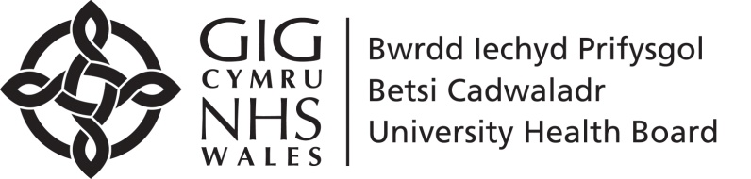

BCUHB Statutory Employment Reports – 2023/24 Commentary
- STAFF IN POST
1a. Age Band
The current staff profile shows a resumption in the trend towards an increasingly ageing workforce:
- The number of Under-25s in the workforce has increased this year to the highest number in the past five years to 887 and now represents 4.24% of the workforce. The number is still disproportionately low compared to 2021 Census statistics (9.37% of population of North Wales). Of applicants for roles with the Health Board, 13.66% were under 25, higher than the North Wales population, and is a marginal increase against last year (13.21%). This may indicate a levelling out of the number of under 25’s applying for posts in the Health Board during the Covid-19 pandemic, which was 34% higher in 2021-22. Research by the North Wales Public Sector Equality Network to support the “Is Wales Fairer?” report showed that unemployment rates are disproportionately high in the under 25 age range.
- In 2020-21, during the pandemic, the percentage of over 60s compared to the number of under 25s in the workforce declined. The reversal of this continues, as data shows that the proportion of over 60s in our workforce increasing to 13.27% - 2775 staff. This is an increase against the 2399 over 60s shown in 2021-22 data. The overall number of staff has increased to 20,909 from 18921 in 2020-21, making the number of over 60s a slightly smaller proportion of the overall staff population that it would have been previously.

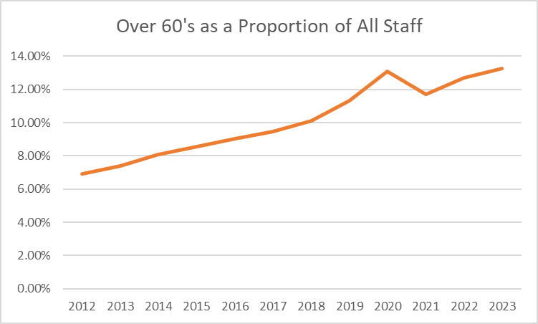

- Whilst the actual number of staff aged 70 or over remains relatively small, there has been a significant proportionate increase over the last 12 years from 56 in 2012 to 205 in 2020. This trend reversed in 2021 (164 staff, 0.87% of the workforce) and has begun to increase again to 198 staff, 0.95% of the workforce in 2023-24.

1b. Disability
We continue to encourage and support employees to update their equality information in ESR, 942 staff have declared a disability (6.15% compared to 4.52% in 2020-21).

In Wales, the age-standardised proportion of disabled people (21.1%) has decreased, compared with 2011 (23.4%), and data from the Annual Population Survey 2015-2017 suggests that across North Wales, 77,000 (18.7%) of people aged 16 to 64 are disabled. However, the “not disabled” category here included those for whom this data is unknown.
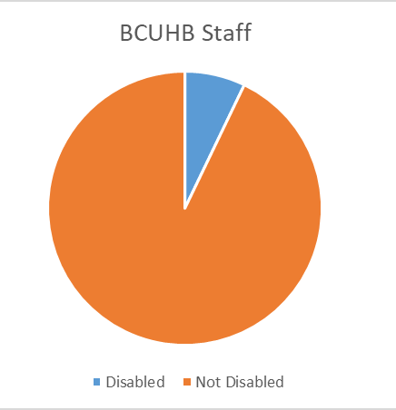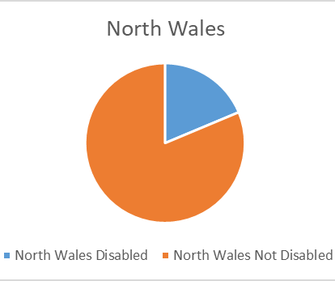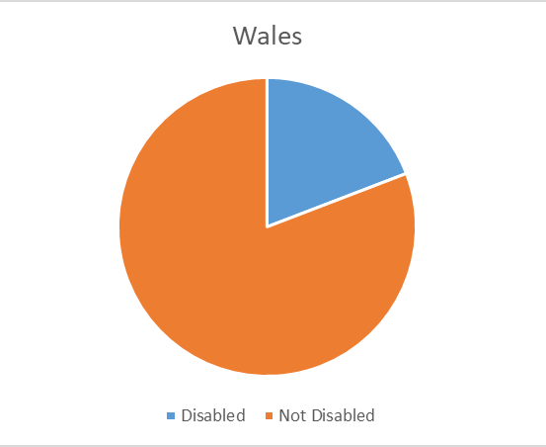
At BCUHB 13.79% of staff (1741) have not disclosed whether they have a long-term health condition, or the information is unknown. This is a reduction against the 2022-23 number which was 14.34% not disclosed or unknown.

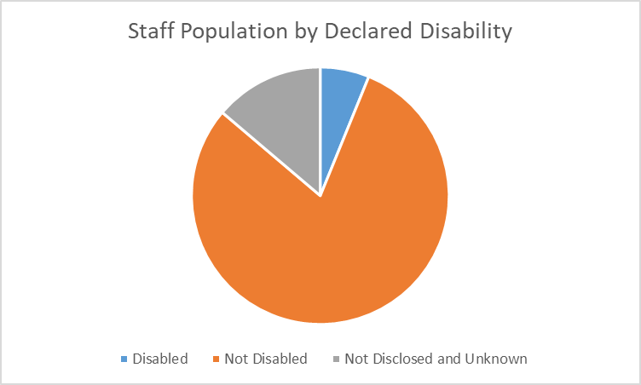

1c. Ethnicity
- The ethnic profile of our organisation has changed since last year. Staff declaring an ethnicity other than white is 6.85% compared to 5.52% in 2022. The proportion of staff declaring Black or Black British backgrounds is almost four times as high as the 2021 Census for North Wales (1.28% compared to 0.36%). The number of staff identifying as Asian/Asian British is more than double the Census (3.68% compared to 1.45%).

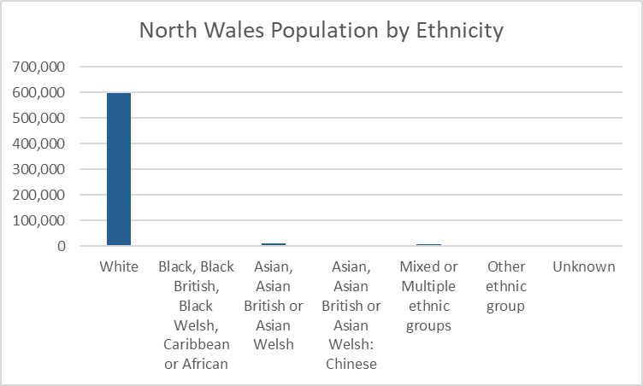
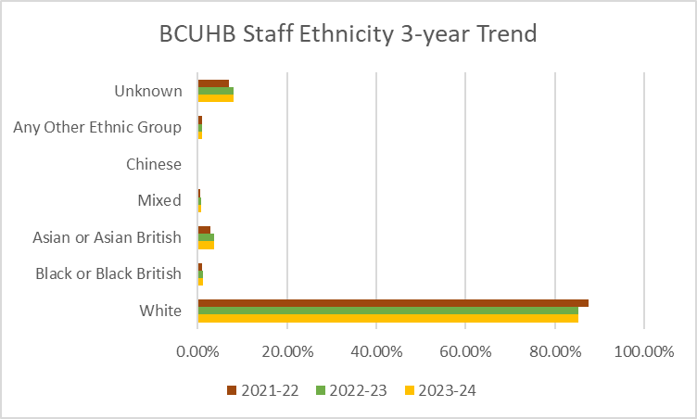

North Wales Population (2021) by Ethnicity and Local Authority Area (including BCUHB %)
(Source: Nomis August 2023)
 | Conwy | Denbighshire | Flintshire | Gwynedd | Wrexham | BCUHB staff
Asian, Asian British or Asian Welsh (including Chinese) | 1.8% | 2.1% | 1.1% | 2.2% | 2.2% | 3.3%
Black, Black British, Black Welsh, Caribbean or African | 0.2% | 0.3% | 0.2% | 0.4% | 0.6% | 1.2%
Mixed or Multiple ethnic groups | 1.1% | 1.1% | 0.9% | 1.1% | 1.2% | 0.7%
White | 96.9% | 96.5% | 97.6% | 96.2% | 96.0% | 86.9%
Other ethnic group | 0.3% | 0.4% | 0.3% | 0.5% | 0.6% | 1.0%
Unknown | 0.0% | 0.0% | 0.0% | 0.0% | 0.0% | 7.0%

We have continued to promote disclosure and support staff to update their personal details in ESR and will continue to do so via payslip messaging and ESR user alerts through 2024-25. The number of staff whose ethnic background is unknown has increased from 1414 on 31st March 2023 to 1659 on 31st March 2024. This represents an increase of 17%.

1d. Gender (Sex)
- The ratio of women and men employed remains unchanged at approximately 80% / 20% and this is reflected in the breakdown of appointments to the Health Board. The split of applicants has changed little since last year. Last Year 64.82% of applicants were women, this year this figure was 65.31%
- 25% less people were appointed this year. The average appointment rate was 4%, with 2% of male applicants appointed, down from 4% last year, and 7.4% of female applicants appointed, whereas in 2022 1.4% of male applicants were appointed and 1.9% of female applicants were appointed.
- The ratio of women to men leaving the organisation is similar, showing that women were slightly less likely than men to leave the Health Board, with a ratio of 77.52% / 22.48%.

1e. Religion and Belief
- There have been no significant changes to the proportions of staff declaring different religions or beliefs in our organisation, although the numbers of people declaring Atheism has continued to rise, and now stands at 14.87%, up from 14.03% last year and 12.83% in 2022. A significant proportion of our staff continue to decline to declare their religion or belief (15.7%), however this has reduced from 2022 (16.46%).
1f. Sexual Orientation
- BCUHB is reporting 2.39% of staff as having declared their sexuality as lesbian, gay or bisexual as at 31st March 2024. This has increased since 2022, where the figure was 1.87%.
The 2021 Census collected data on sexual orientation for the first time. and from comparing BCUHB results with the census we can see that the results are broadly similar, with the most significant differences being the percentage of respondents declaring themselves heterosexual being lower in BCUHB and the ‘not disclosed’ number being higher in BCUHB. One could make a tentative assumption that each category would rise proportionately if the disclosure rate increased to 100%.
In 2023-24, 8.32% of staff did not disclose their sexual orientation information, which is an improvement from 11.65% undisclosed on 31st March 2022.
- the Equality Team’s efforts to promote and support staff declaration in ESR is likely to have continued to contribute to the reduction in the undisclosed number.
- The Comparison between the 2021 census and the BCUHB data can be seen here:

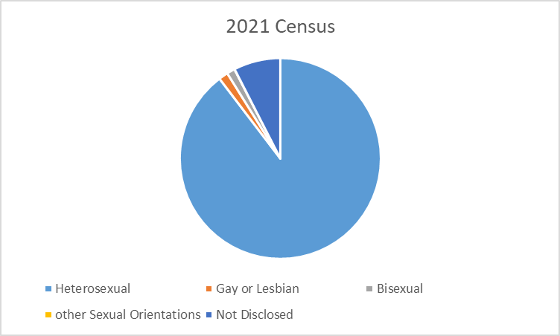
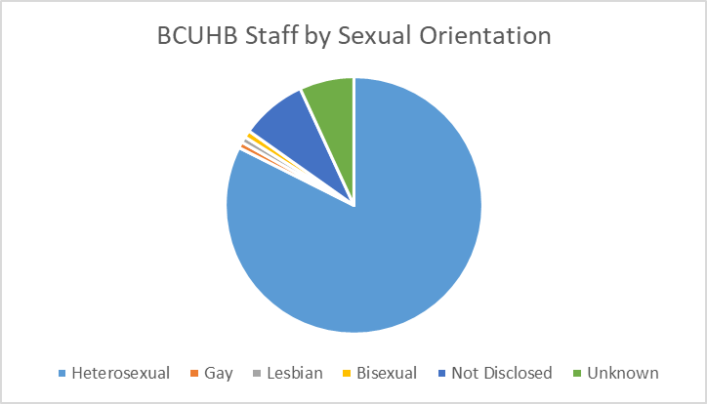
Note:
The following responses have been categorised as follows:
Not stated (person asked but declined to provide a response) – Not Disclosed
Undecided – Not Disclosed
Other sexual orientation not listed – Not Disclosed
Unspecified – Unknown

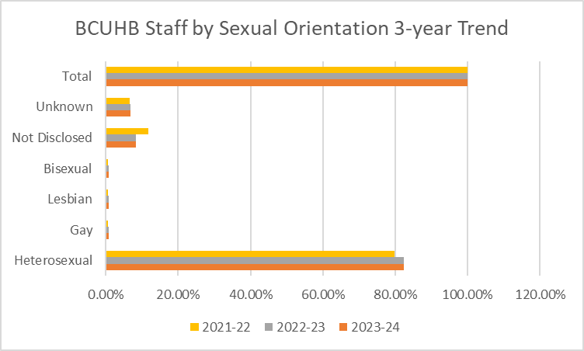
1g. Marital Status
Office of National Statistics 2020 population estimates show that 50.6% of people over the age of 16 in England and Wales are married. This percentage is very similar in the Health Board at 50.73%. This figure has dropped since 2022 and 2021, which was 51.65 % and 53.09% respectively. Only 44.84% of applicants to the Health Board were married, and a lower number again were appointed (39.91%).
Notably, this year has seen a further decrease in applicants not stating their marital status. For the year ending 31st March 2021, 18.18% of applicants did not state their marital status compared with 1.6% for the year ending 31st March 2022 and 0.13% for the year ending 31st March 2024.
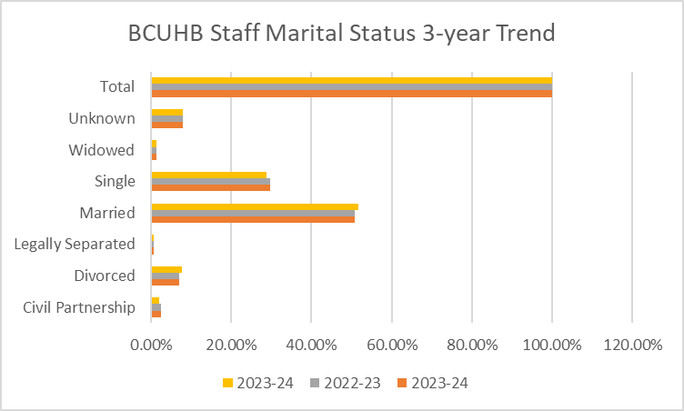

- STAFF INVOLVED IN DISCIPLINARY OR GRIEVANCE CASES
Findings of note when considering the proportion of staff from protected characteristic groups involved in disciplinary and grievance cases compared to the proportion all staff involved in disciplinary and grievance cases are as follows:
- There are proportionately 13% more men involved in disciplinary cases and 12% more men were involved in grievance cases than women when compared to the ratio of men and women in the organisation.
- The age groups with proportionately higher involvement in disciplinary cases are the Under 25, 25-29, 30-34, 40-44, 45-49, and 55-59 age groups, which is the highest, as the 55-59 age group constitutes 13.86% of the staff population but accounts for 17.2% of all disciplinary cases. The over 70 age group, a cohort of 198 staff has had involvement in less than 5 disciplinary cases.
- Men also submit proportionately more grievance cases, with 32.58% of cases.
- 36.4% of all grievance cases involve staff in the 50-59 age group.

- When we consider disciplinary and grievance cases by ethnicity, we do not see a significant difference between cohorts against their size in the organisation, however the number of Asian employees involved in disciplinary cases is 0.61% higher than the proportion of the employee population that Asian staff hold. The numbers of other ethnic minority staff involved in disciplinary cases are too low to register.
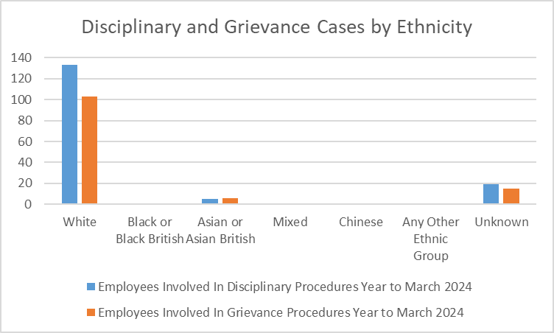
Notable, Asian staff account for 4.55% of grievance cases (6), but only account for 3.68% of the staff population. This indicates that there may not be a significant fear or reticence to speak up.
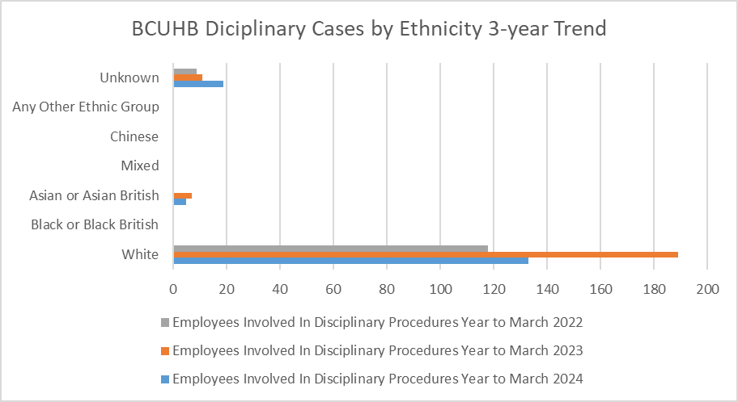
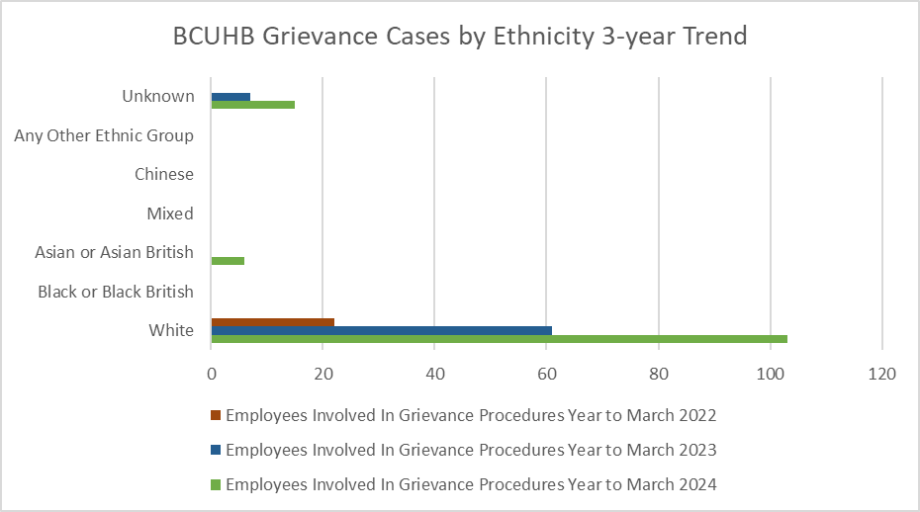

- PAY, BAND AND STAFF ROLES
3a. Gender Pay, Band and Staff Role
- Average pay for male staff continues to be higher. Overall, the average pay of male employees is £45,848 compared to £35,348 for females. This is reflected in every staff group, except allied health professionals and students, with the biggest gender pay gaps appearing in administrative and clerical roles and medical and Estates and Ancillary roles.

- Women are over-represented in the most grades. 91.4% of female employees are employed at band 7 or below, compared to 74.27% of males. This is largely unchanged from the previous year.

- Female employees are more likely to be on a permanent contract. 96.51% of female employees are permanent compared to 93.1% of male employees.

- However female employees are far more likely to work part time than male colleagues. 48.58% of female employees are on part time contracts compared to 20.84% of male employees.

- There remains a significant difference in the proportion of consultants by gender. Across BCUHB, 2.89% of staff are consultants. Just 1.17% of our female employees are consultants, whereas 10.16% of our male employees are consultants. Males account for 67.44% of consultant roles which receive a higher level of pay award, and this will be the most likely contributor to a gender pay gap. This has dropped from 2023, when males accounted for 69.3% of consultants.

3b. Age and Pay
- Average pay across different age bands shows a distribution curve that is broadly what we would expect to see. Earnings rise as people get older, gain more experience and progress up pay scales. As people reach 50 and beyond, we would expect a reduction as staff elect to take advantage of flexible working patterns to reduce their working hours, work less additional hours and access early retirement options.
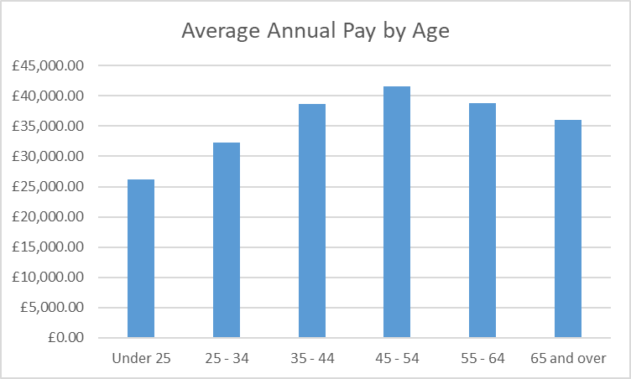
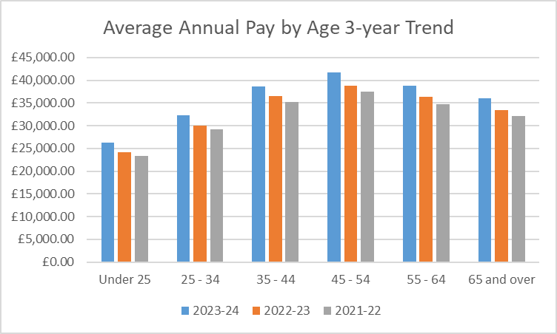
3c. Disability and Pay
- The average pay of disabled staff is lower than that of those that have not declared whether they have a disability or not (“Not declared or undefined”). The same applies to staff that have declared that they do not have a disability.
- Staff who have declared a disability have an average annual pay 16.88% lower than those that are Not declared or undefined.
- Staff who have declared that they do not have a disability have an average annual pay 11.74% lower than those that are Not declared or undefined.
- The pay gap between all staff that have declared a disability and those that have declared that they do not have a disability is 5.81% in favour of the “not disabled” cohort.
- This has reduced from 8.25% in 2021-22. Looking at the staff groups, the disability pay gap is highest in administrative and clerical positions (-3.65%). Notably, no students declared a disability in the data for last year, however, this year students declaring a disability showed a positive pay gap of 11%.
- In the Medical and Dental staff group, average pay for disabled staff is also higher than that of non-disabled staff with a 13.93% difference.

4d. Ethnicity and Pay
- Average pay for staff from white backgrounds is less than all other Ethnic Groups. 68.3% of our Black, Asian and Minority Ethnic staff are employed in medical and dental or nursing and midwifery professions which largely explains this difference. On average, the highest paid ethnic group are Asian/Asian British employees.

4e. Religion or Belief and Pay
- Average pay for staff who have declared their religion as Sikhism, Hinduism or Jainism is higher than all other groups. This is largely because the majority of staff declaring these religions are employed within Medical and Dental Staff Group where average earnings are significantly higher than any other staff group. Those declaring their religion or belief as Other, Atheism or Christian are the lowest paid.

4f. Sexual Orientation and Pay
There is a negligible difference in average pay between the heterosexual and gay/lesbian staff groups, but staff declaring themselves bisexual have a lower average pay. Staff declining to declare have a higher average pay than all other groups.

- APPLICANTS TO THE HEALTH BOARD
There are some interesting differences in the profile of those applying for roles within the health board compared to that of those appointed.
- People between the ages of 25-34 make up the largest cohort of applicants, accounting for 55.44% of applicants. This cohort also, as one might expect, accounts for the largest cohort of successful applicants, making up 31.5% of all those appointed. In 2020-21, this was true for the 35-39 age group, so the biggest cohort of applicants has remained younger. When considering the ageing employee population, this result reinforces the idea that the ageing workforce is due to employees staying with the organisation throughout their working lives.
- In terms of actual success rate, those from the 55-59 age range have the most success when applying to the health Board. This relates to a sizeable number of positions, with 203 roles appointed to from a cohort of 1417 applicants, meaning 14.33% of those who applied were appointed. The number of applicants is smaller than most other age groups.
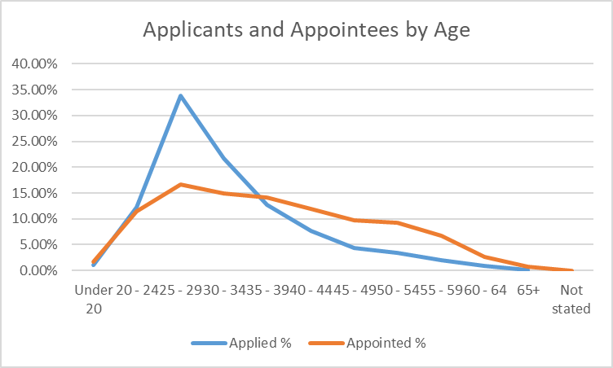
- 2.62% of applicants to the Health Board declared a disability and accounted for 6.08% of appointees.
- 2021 census data that indicates approximately 21.1% of the population in Wales declared a disability or long-term health condition¹

¹Disability, England and Wales - Office for National Statistics (ons.gov.uk)

- 96.46% of applicants declared no disability and accounted for 89.81% of appointees.
- 0.14% of applicants did not state whether they had a disability, yet this cohort accounted for 2.54% of appointees.
- White applicants are most likely to be appointed. 15% of White applicants were appointed. 12% of applicants who did not state their ethnicity were appointed. 34.94% of applicants were Black or Black British yet successful applicants from this group were just 2.37%. Initial work to understand this result suggests the used of automated electronic job applications from international applicants which may be skewing the data. Further work is planned to understand this better.
30.39% of applicants were Asian or Asian British and 6.45% of appointees were from this group.
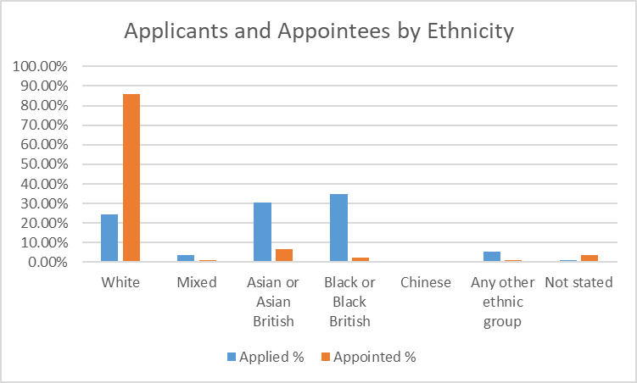

- In 2021-22, 11.95% of applicants to the Health Board declared their religion or belief as Islam. In 2023-24 this figure is 17.76% This group made up 2.2% of appointees, however in 2020-21 0.97% of successful applicants were Muslim. The religious group most likely to be appointed are those who did not wish to state their religion. This group accounted for 0.14% of applicants, yet 2.54% of appointees; a success rate of 77.55%.
- 65.31% of applicants were female. When we look at appointments we see that 81.5% of final appointees were female, almost 1% higher than the female employee population number.

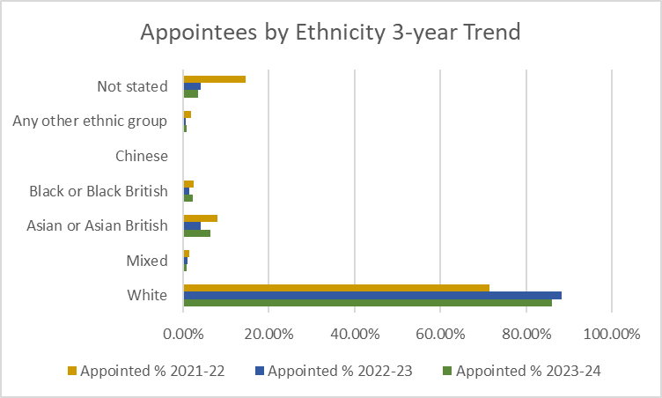

- STAFF WHO LEFT BCUHB

- The split of leavers by male and female is 22.48% men to 77.52% women. When we recall that the staff population is 19.19% men to 80.81% women, we can see that men are more likely to leave than women.
- As of 31st March 2024, over 55s made up 44.97% of leavers in one year. This has dropped from 46.16% in 2022, but is still a significant cohort. This is largely explained by retirements and early retirements which we would expect to see, and likely influenced by the residual impacts of the pandemic and impacts of workforce unrest and recognised difficulties in the NHS seen in recent years. Despite this, over 60s account for 13.27% of the overall workforce – nearly twice the proportion of 2014, and the highest number since these records began in 20212.
- 74.44% of leavers declared themselves not disabled in 2023-24 and 18.84% of staff who left BCUHB had either not declared a disability or their disability status was unknown (compared to 13.79 % of all staff), and 6.72% are disabled leavers. There is a lower proportion of staff leaving who had declared that they are not disabled than the overall profile (74.44% of leavers and 80.06% of the workforce profile.
- White employees make up a lower proportion of leavers than they do the overall staff profile. 88.34% of leavers were white compared to the White workforce profile of 85.22%. Conversely, Black or Black British make up 1.28% of the workforce profile, but make up 2.98% of leavers. From this we can conclude that White and Asian or Asian British staff are less likely to leave than Black or Black British staff.
- Staff whose ethnicity is unknown account for 11.14% of leavers, but account for only 7.93% of the staff population.
- Asian or Asian British staff make up 3.68% of the workforce profile and 3.7% of leavers.
