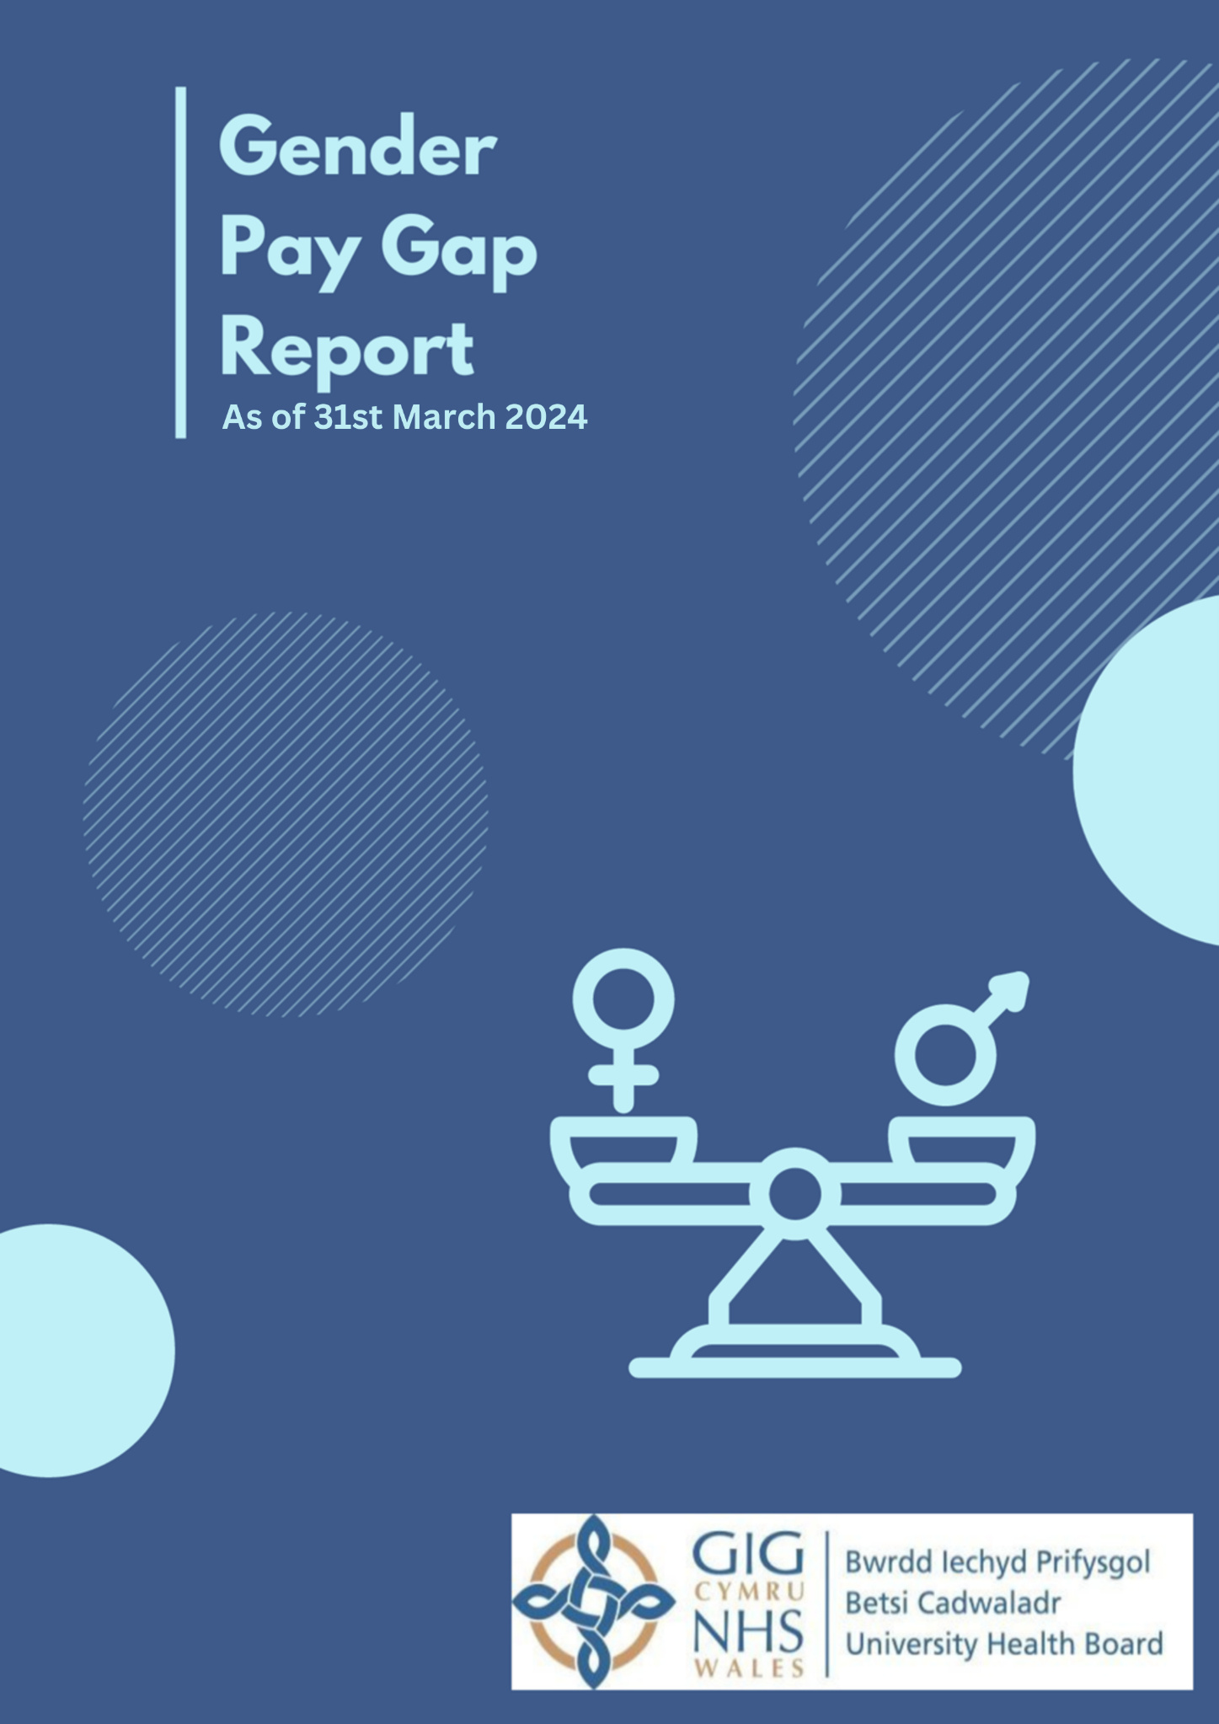

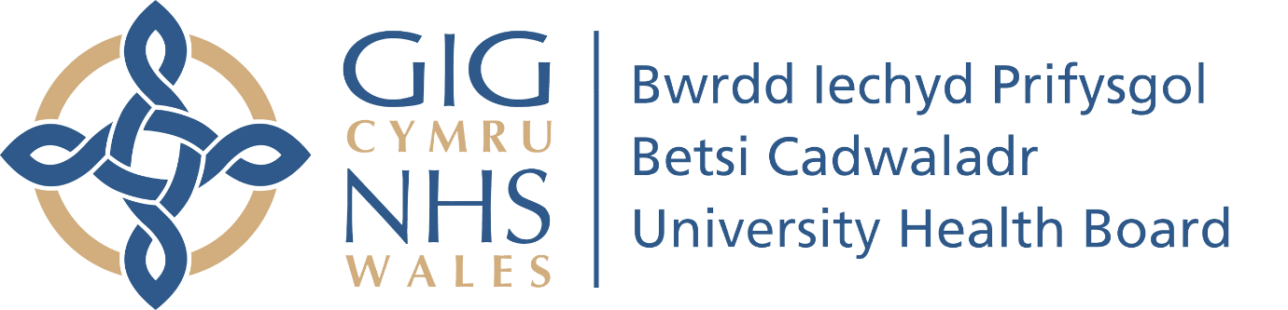

Betsi Cadwaladr University Health Board
GENDER PAY GAP REPORT – 31st MARCH 2024
Index of Contents

Introduction 3
1. What is covered in this report 3
Key Reporting Metrics: 4
Mean Gender Pay Gap in hourly pay 4
Median Gender Pay Gap in hourly pay 4
Proportion of males and females in each pay quartile 4
Gender pay reporting and gender identity 4
2. Combined Agenda for Change and non-agenda for change Pay data 5
Mean and Median Rates 5
Bonus Payments 6
The proportion of staff receiving a bonus** 7
Quartile Data 7
Gender Pay Gap by Pay Band 9
3. Progress on Closing the Gender Pay Gap 10
4. Next Steps 10
5. Conclusion 11
6. STATEMENT BY OUR HEAD OF EQUALITY AND HUMAN RIGHTS 11

Introduction

The gender pay gap reporting obligations are outlined in The Equality Act 2010 (Gender Pay Gap Information) Regulations 2017. As an organisation that employs more than 250 people Betsi Cadwaladr University Health Board (BCUHB) must publish and report specific information about our gender pay gap on our own and Welsh Government’s website.

The regulations state that the Gender Pay Gap Information should be provided as a snapshot on 31st March each year and published before the following March.

It is important to recognise and understand that the Gender Pay Gap differs from Equal Pay. Equal Pay means that men and women in the same employment performing ‘equal work’ must receive ‘equal pay’, as set out in the Equality Act 2010. It is unlawful to pay people unequally because of their gender. The NHS Agenda for Change Job Evaluation process evaluates the job and not the post holder. This job evaluation process looks at the job without reference to gender or any other protected characteristic so equal pay is assured.

Gender pay gap reporting is a valuable tool for BCUHB not only in terms of compliance but also for the organisation to assess levels of equality in the workplace. Specifically, in respect of female and male participation, and how effectively talent is being maximised.

The Gender Pay Gap report focuses on comparing the pay of male and female employees and shows the difference in average earnings.

What is covered in this report

This report provides the following information based on ordinary pay which includes basic pay and shift pay and allowances. A further report will be provided that breaks down Agenda for Change and Non Agenda for Change pay to give a more comprehensive picture above what is required by statutory reporting requirements.

Key Reporting Metrics:

Mean Gender Pay Gap in hourly pay

The mean hourly rate is the average hourly wage across the entire organisation, so the mean gender pay gap is a measure of the difference between women’s mean hourly wage and men’s mean hourly wage.

Median Gender Pay Gap in hourly pay

The median hourly rate is calculated by arranging the hourly pay rates of all male or female employees from highest to lowest and finding the point that is in the middle of each range.

Proportion of males and females in each pay quartile

Pay quartiles are calculated by ranking all employees from highest to lowest paid and dividing this into four equal parts or ‘quartiles’ and working out the percentage of men and women in each of the four parts.

This report does not look at whether there are differences in pay for men and women in equivalent post, or WTE at the size of the role. This means that the results will be impacted by differences in the gender composition across groups and job grades.

Gender pay reporting and gender identity

Current Advisory, Conciliation and Arbitration Service (ACAS) and government guidance suggests that if an individual doesn’t identify with either gender they should be excluded from the report. We recognise that this excludes employees who do not identify as either ‘male’ or ‘female’ i.e., transgender or non-binary employees and are aware of the importance of being sensitive to how an employee chooses to self-identify in terms of their gender. Regulations do not define the terms ‘male’ and ‘female’ and the requirement to report gender pay should not result in employees being singled out and questioned about their gender. We are therefore using the data provided by Electronic Staff Records (ESR) based on the gender identification the employee has provided as the means for determining male and female employees.

Combined Agenda for Change and non-agenda for change Pay data

Agenda for Change (AfC) is the current NHS grading and pay system for NHS staff, with the exception of doctors, dentists, apprentices and some senior managers.

The AfC system allocates posts to set pay bands by considering aspects of the job, such as the skills involved, under an all-Wales NHS Job Evaluation Scheme. There are twelve numbered pay bands subdivided into points.

A set of national job profiles has been agreed to assist in the process of matching posts to pay bands. All staff will either be matched to a national job profile, or their job will be evaluated locally.

AfC is designed to evaluate the job rather than the person within it, and to ensure equity between similar posts in different areas.

The Non-Agenda for Change (Non-AfC) group which includes Medical, Dental and Senior Manager salaries reflects the highest paid positions within the Health Board.

As of 31st March 2024, BCUHB employed 19,990 women and 4968 men therefore 80% of the workforce were female.

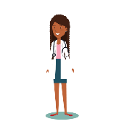 | Female:  80%  (19,990) |  | Male: 20%  (4968)

Gender | People | %
Female | 19990 | 80.09%
Male | 4968 | 19.91%
Grand Total | 24958

Mean and Median Rates

 | Mean Hourly Rate | Median Hourly Rate
Male | 24.67 | 18.31
Female | 18.86 | 17.09
Difference | 5.81 | 1.21
Pay Gap % | 23.58 | 6.65

Mean Gender Pay Gap = 23.58%; Median Gender Pay Gap = 6.65%

The average is calculated over different numbers of employees, we employ 15,022 more female employees than male therefore this will account for some of the variance.

Women’s mean hourly rate is 23.58% lower than men. In other words when comparing mean hourly rates, women are paid 76.42p for every £1 that men get paid.

Women’s median hourly rate is 6.65% lower than men. In other words when comparing median hourly rates, women are paid 93.35p for every £1 that men get paid.

Mean Hourly Rate Pay Gap Trend

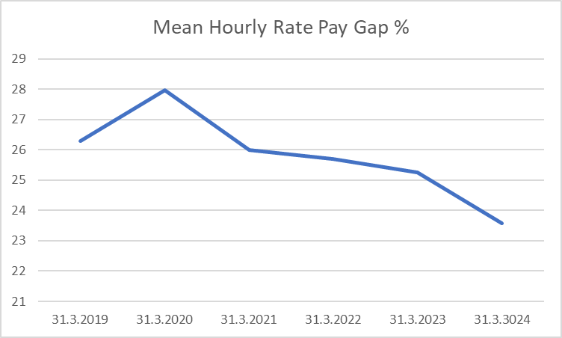

Median Hourly Rate Pay Gap Trend

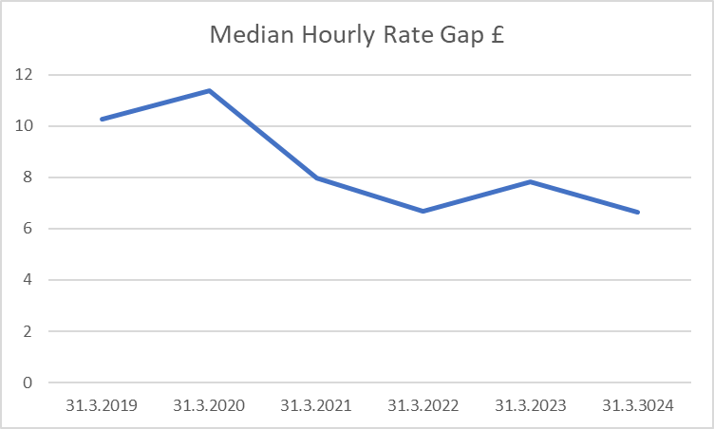

Bonus Payments

Gender | Average Bonus (£) | Median Bonus (£)
Male | 12,276.58 | 11,905.14
Female | 10,014.17 | 10,002.00
Difference | 2,262.41 | 1,903.14
Pay Gap % | 18.43 | 15.99

In line with the reporting requirements, our Average bonus gap of 18.43% is based on actual bonuses, so it does not consider part-time work. This gap has increased from the previous year’s figure of 13.98% in 2023. The median bonus gap has increased from 5.31% to 15.99%. This is the midpoint in the range of bonuses that male and female staff received; this would suggest that the value of bonuses received by men at the high end of the range has increased, while the equivalent for women has decreased very slightly. 10 more men received a bonus this year compared to last year. The number of women receiving a bonus increased by 7. The number of men receiving a bonus continues to be almost exactly three times that of women.
Average Bonus Pay Gap Trend
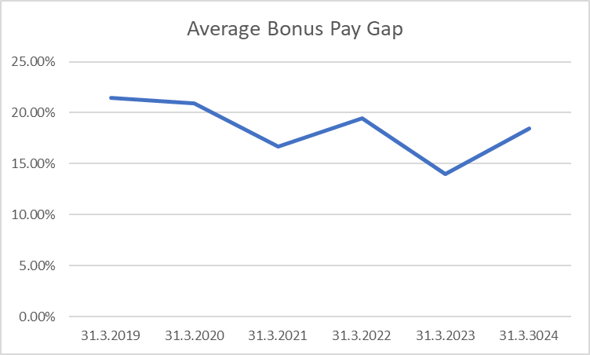

Median Bonus Gap Trend
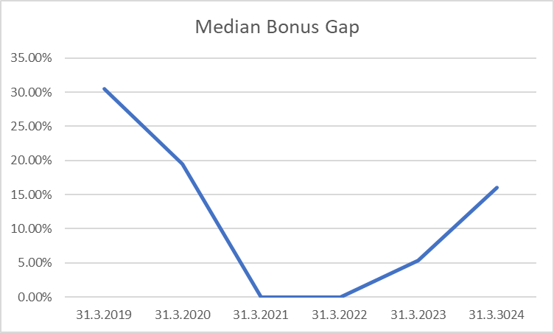

The proportion of staff receiving a bonus**

Gender | Employees Paid Bonus | Total Relevant Employees | %
Female | 83 | 19999 | 0.42
Male | 248 | 4968 | 4.99

** Bonus payments comprise Clinical Excellence and Commitment Awards paid to medical staff.

Quartile Data

The quartile data ranks our employees from highest to lowest paid, this is divided into four equal parts, or quartiles, and describes the percentage of men and women in each.

Quartile | Female | Female % | Male | Male %
1 | 4509 | 83.02 | 922 | 16.98
2 | 4469 | 82.20 | 968 | 17.80
3 | 4656 | 85.65 | 780 | 14.35
4 | 3956 | 72.77 | 1480 | 27.23

Quartile 1: Lower quartile (lowest paid)

 | 83.02%  (4,509) |  | 16.98%  (922)
16.98% of the lower quartile are men

Quartile 2: Lower middle quartile

 | 82.20%  (4,469) |  | 17.80%  (968)
17.80% of the lower middle quartile are men

Quartile 3: Upper middle quartile

 | 85.65% (4,656) |  | 14.35%  (780)
14.35% of the upper middle quartile are men

Quartile 4: Upper quartile (highest paid)

 | 72.77%  (3,956) |  | 27.23%  (1480)
27.23% of the top quartile are men

The highest variances are in the upper quartile.

51.05% (8978) of females were in roles within the lower and lower middle quartiles and 48.95% (8612) in the upper middle and upper pay quartiles. This compares with 45.54% (1,890) males in the lower and lower middle quartiles and 54.46% (2260) in the upper middle and upper pay quartiles.

Lower and Lower Middle Pay Quartiles

 | 82.55%  (8,978) |  | 17.39%  (1,890)

Upper Middle and Upper Pay Quartiles

 | 79.21%  (8612) |  | 20.79%  (2260)

Gender Pay Gap by Pay Band

The table below shows the ratios of male to female staff across the pay bands.

Pay Band | Female | Male
Band 2 | 19.23% | 21.42%
Band 3 | 15.14% | 13.28%
Band 4 | 9.01% | 5.70%
Band 5 | 19.88% | 13.28%
Band 6 | 17.94% | 11.88%
Band 7 | 10.19% | 8.72%
Band 8a | 3.25% | 3.36%
Band 8b | 0.98% | 1.30%
Band 8c | 0.69% | 1.10%
Band 8d | 0.24% | 0.67%
Band 9 | 0.15% | 0.27%
Non-Agenda for Change | 0.20% | 0.40%
Associate Specialist | 0.12% | 0.50%
Clinical Assistant | 0.00% | *
Consultant | 1.17% | 10.16%
Dentist | 0.17% | 0.50%
Foundation Yr 1 / Yr 2 | 0.11% | 0.30%
Other Medical | 0.36% | 0.85%
SHO / House Officer | 0.00% | 0.00%
Specialty Doctor / Staff Grade / Trust Grade | 1.05% | 5.70%
Specialty/Specialist Registrar | 0.11% | 0.47%

Figures below 5 are suppressed and denoted by *

Breakdown of bands in each AfC Employees quartile
Quartile 1 Bands 1-3
Quartile 2 Bands 4-5
Quartile 3 Bands 6-7
Quartile 4 Bands 8a-9

Progress on Closing the Gender Pay Gap

The Health Board recognises that there are factors outside of our control or influence which are impacting on pay. We have made a clear commitment in our Strategic Equality Plan to take action to understand our pay gaps, and address and minimise the impact within the constraints of the national pay systems for the NHS.

Next Steps

The Health Board has several key documents that identify the importance of fair recruitment, staff wellbeing and equity. These include our People Plan, our current Strategic Equality Plan 2024-2028 and our Integrated Medium-Term Plan. These strategic documents outline the Health Board’s plans for addressing our pay gaps and pay differences.

We will consider how to improve and promote by:

- Using data in Pulse surveys, staff wellbeing and the NHS staff survey to identify areas of support needed such as work-life balance needs, career progression and training opportunities to ensure staff have all the opportunities to develop and progress in the Health Board.
- Raising awareness of shared parental leave and other work-life balance options. Improving attitudes to flexible working and part time working across a wider range of roles.
- Exploring data across pay bands and all the different roles within the organisation. Recognising the intersectionality of barriers that can impact on career progression.
- Exploring how to increase recruitment in underrepresented areas through widening access schemes, including exploring options for improving recruitment training for managers.
- Looking at ensuring leadership and personal development opportunities are not just aligned with academic attainment, reflecting that not all staff have opportunities to attend college and universities but still have the potential to be leaders in the Health Board.
- Identifying those areas where the offer of reverse mentorship would support staff into leadership roles where there is under representation.
- Continuing to promote agile working within the Health Board.
- Providing active bystander training as part of recruitment training for managers.
- Continuing and grow menopause support for staff, recognising the impact menopause can have on personal development and staff retention.
- Working with external partners on DWP (Department for Work and Pensions) initiatives such as employability schemes, apprentices, and mentoring.

Conclusion

Over the past 2-3 years, the Health Board has not seen a significant improvement in its pay gap, which has remained around the 25-28% mark. This year, however, we have seen an improvement from a mean hourly rate of £25.25 and median hourly rate of £7.84 last year to a mean hourly rate of £23.58 and median hourly rate of £6.65 this year. In addition, we are now seeing emerging evidence that the cost-of-living situation is impacting on our workforce as staff are leaving the NHS to work in other sectors.

In the Health Board we have significant nurse vacancies which we know has a predominately higher female uptake. These vacancies have a significant impact on our workforce data.

This report highlights the disproportionate imbalance of pay for men in Non-AfC roles relative to women.

Also worth noting, at this current time, is that the Health Board no longer employs junior doctors. They are now employed by NHS Wales Shared Services to facilitate their rotational training across NHS Wales.

In recent years there has been more female junior doctors coming through training. The impact of this is that we should start to see a greater balance of genders in medical and dental roles over the next 10 years. This should then address the imbalance we currently see in the pay gap across all roles in the NHS.

Betsi Cadwaladr University Health Board remains committed to promoting equality, diversity and inclusion. We will use the lessons we are learning through our gender pay gap discussions to inform the work we undertake looking at other potential pay gaps within the organisation.

STATEMENT BY OUR HEAD OF EQUALITY AND HUMAN RIGHTS
“Pay gap reporting is very important in understanding women’s position our organisation, and the differences between women and men’s pay and bonuses in BCUHB.
Healthcare roles, and in particular nursing are widely recognised as being more commonly occupied by women. Despite this, gender pay gaps typically occur in NHS organisations as men tend to occupy more of the senior medical workforce roles. 80% of our workforce is female, however 67% of our medical consultants are male. This factor influences our bonus pay gap, and our medical workforce benefit from Clinical Excellence and Commitment Awards.
We are committed to tackling all forms of inequality, including gender inequality at work. Creating a culture of inclusion, fairness, and equity across our workforce is at the heart of our People Strategy and Plan.
With this in mind, we will continue to improve our understanding of the professional experiences of women in our medical workforce to ensure equitable career progression between men and women, inclusive of non-binary colleagues. The continued development of the BCUHB Gender Equality Network (GEN) and our commitment to promote and improve sexual safety in healthcare will contribute towards these goals.
We are very encouraged to see that our average hourly rate pay gap and median hourly pay gap have both reduced this year”.

