Equality Annual Report
2024-25
Author: Ceri Harris

Contents
Accessibility Statement 4
Foreword 5
Executive Summary 6
Building an effective organisation: 6
Developing strategy and long-lasting change: 6
Creating compassionate culture, leadership and engagement: 6
Improving quality, outcomes and experience: 6
Establishing an effective environment for Learning: 7
Progress Made 7
Barriers and Risks 7
Conclusion 7
Section 1: Introduction 8
Structure of this report 8
Special Measures 8
#TheBetsiWay 9
Population 9
Section 2: Background / Context 10
Anchor Institution 10
Our Strategic Equality Plan 10
Our Equality Objectives 2024-2028 10
Governance arrangements 11
Statutory reporting 12
Strategic Equality Plan 12
Equality Annual Reports 12
Section 3: Review of the Year 2024/25 12
3.1 Focus on National Plans - linked to objectives 13
3.1.1 Welsh Government Anti-racism action plan and progress 13
3.1.2 Welsh Government – LGBTQ+ Action Plan 13
3.1.3 Code of Practice on the Delivery of Autism Services 14
14
3.1.4 All Wales Standards for Accessible Communication 14
3.1.5 The Health Board’s Three-Year Plan Strategic Objectives 2024-2027 144
3.1.6 Three Year Plan: Strategic Objectives 15

Building an effective organisation 16
Developing a strategy and long-lasting change 19
Creating compassionate culture, leadership and engagement 25
Improving quality, outcomes and experience 38
Establishing an effective environment for learning 47
Section 4: Priorities for the Year Ahead 2025/26 51
Section 5: Conclusion 52
Appendices 54
Appendix A: Population information 54
Appendix B: Equality legislation and Strategic Context 54
Appendix C: BCUHB Vision, Values and Purpose 54
Appendix D: Equality Matrix 54

Accessibility Statement

This report and any supporting documents are available in Welsh, and can be made available in other languages and formats on request.

For other formats, please contact: Patient Advice and Liaison Service
Tel 03000 851234
BCU.PALS@wales.nhs.uk

To Contact the Equality Team at BCUHB email:
BCBCU.Equality@wales.nhs.uk

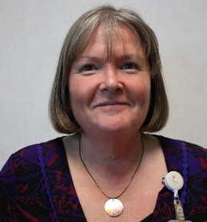
Georgina Roberts

Interim Executive Director of People, Workforce and Organisational Development

Foreword

Welcome to Betsi Cadwaladr University Health Board’s (BCUHB) Annual Equality Report for the period April 2024 to March 2025. This report highlights key activities and progress made in advancing equality and human rights across the Health Board during this time.

The work outlined in this report aligns with the priorities set out in the Health Board’s
2024–2027 Three-Year Plan, which provides the strategic framework for the period
covered. In addition, it reflects the first year of delivery against our Strategic Equality
Objectives and Action Plan 2024–2028.

As the largest Health Board in Wales, it is not possible to capture every initiative, project, or service that contributes to inclusive, patient-focused care. Instead, this report offers a spotlight on selected areas of work that exemplify our commitment to equality, diversity, and inclusion.

The past few years have brought significant change and challenge. In 2024–2025, our
focus has been on Stabilisation, Standardisation, and Sustainability—prioritising actions that will have the greatest impact on improving the health and wellbeing of the North Wales population.

The Health Board has continued to embed robust processes that promote equity in decision-making and
strategic planning. We have also worked to raise the profile of equality across staff
groups, senior leadership, and the Board.

This period has also seen a strengthened focus on public engagement, co-production,
and building meaningful relationships with underserved and systemically marginalised communities. These efforts support our delivery of Welsh Government equality-focused plans, including the Anti-Racist Wales Action Plan, the LGBTQ+ Action Plan for Wales, the Code of Practice for Autism, and the NHS Wales Women’s Health Plan. These frameworks are central to improving experiences for both our communities and our workforce.

The Health Board is confident that this report demonstrates our ongoing commitment to equality, diversity, and inclusion, and the tangible progress made throughout 2024–2025.

Executive Summary

This Equality Annual Report provides information on the progression of the Health Board activity and related work for the first year of the BCUHB Strategic Equality Plan 2024-2028.

During 2024/25, the Health Board has centred equality and inclusion activities that relate to the five Equality Objectives and aligned to the BCUHB Three-Year Plan as summarised below.

Building an effective organisation:

The Health Board has made improvements to the quality and range of information to support decision makers, including senior leaders to meet the statutory Equality Duty and Socio-economic Duty. This has helped identify impacts for those who share protected characteristics and embed processes to mitigate possible adverse impacts.

During 2024/25, all key transformation plans followed the processes and procedures to evidence due regard in decision making.

Developing strategy and long-lasting change:

During 2024/25, a strong focus has remained on implementing Welsh Government Plans, including the Anti Racist Action Plan and LGBTQ+ Action Plan. In December 2024, the NHS Wales Women’s Health Plan 2025-2035 was published which has generated much work to start implementing the plan to address women’s health inequalities.

A focus on preventative health interventions such as vaccination programmes, innovative partnership working to reduce health inequalities and responding to new legislation such as the white paper for ending homelessness.

Creating compassionate culture, leadership and engagement:

During 2024/25, there was good visibility of cultural celebrations and inclusion related awareness campaigns, of which were shared across the Health Board and are supported by Staff Equality Networks. A range of co-production work had been undertaken during the year across clinical teams and involving external Equality Stakeholders.

During 2024/25, the Health Board carried out work to review the Organisational Values and Behaviours which directly relates to the Three-Year Plan and the BCUHB Strategic Equality Objectives.

Improving quality, outcomes and experience:

Compliance with equality and human rights legislation has a direct impact on patient and carer experiences, as well as those of staff and the wider population of north Wales. Work has been undertaken during 2024/25 to promote understanding of the issues of dignity, respect and aligned to a Human Rights Approach.

Different approaches to meet the individual needs of patients, carers and staff highlights how health outcomes can be achieved with groups who experience inequalities and social disadvantage.

Establishing an effective environment for Learning:

There have been a number of innovative projects that support the Strategic Equality Plan and related equality plans from Welsh Government. The links between the Health Board and Bangor University and Wrexham Glyndwr University are strong. An addition to equality and inclusion training for student nurses, there are research projects also in place.

Progress Made

Significant progress has been made to embed equality within the Health Board’s corporate strategies and ensure equality impact assessments (EQIA’s) and socio-economic risks assessments are undertaken and quality checked. The re-establishment of the EQIA Scrutiny group provides another level of scrutiny and quality control of key assessments. Teams across the Health Board have signed up to complete the Diverse Cymru cultural competence certification scheme, and there has been promotion of equality work through newsletters, the BCUHB intranet, public engagement activities and partnership events.

Barriers and Risks

It is unlikely to be surprising that financial pressures place challenges on the scale and scope of the Health Board’s Strategic Equality Plan. One example is the training demands for 20,000 staff to help address specific equality issues that are not covered by the mandatory ‘Treat Me Fairly’ e-learning module are particularly challenging.
Additionally, the Health Board recognises the need for regular equality development sessions to ensure that Board members are kept fully up to date on the requirements of current national action plans and legislation

Conclusion

The focus for 2024/25 was to build visibility of Equality, Diversity, and Inclusion into all aspects of the Health Board’s workforce and service delivery. Staff have worked extremely hard to improve services and embed equality to meet the legal requirements under the Equality Act 2010, building on the positive work that has previously taken place. The Health Board plans to move forward into year 2 of the four-year Equality Plan using good practice and innovative ideas.
Key Priorities for 2025/26 include:
- Review inclusive recruitment, progression and retention.

- Focus on improvement of baseline equalities data and its analysis.

- Analysis of Equality based pay gap data.

- Focused Engagement with underrepresented groups.

Section 1: Introduction

Structure of this report

Promoting equality, inclusion and valuing diversity are all fundamental to accessing health care and addressing better health outcomes. The following report is divided into different sections, providing information and evidence demonstrating how we have discharged our equality duty.
This evidence includes:
- Delivering on the Equality Duty – Public Sector Equality Duty and Socio- economic Duty
- Strategic Equality Objectives and Plan 2024-28 – Developing our objectives

Special Measures

In February 2023, the Health Board was placed back into Special Measures. The Health Board recognises that there is significant progress to be made in the leadership and culture of our organisation, and equality and inclusion alongside compassionate leadership will be at the heart of these improvements. It also recognises the impact that has on our workforce and public reputation.

The Health Board has had to adapt our services and move to work with our community, its public services partners, our volunteers, and our employees to ensure BCUHB provides a high standard of care and services ensuring we meet our commitments to deliver quality care, and excellence.

As a response to being placed in Special Measures the Health Board has identified its five core outcomes.

- Outcome 1: Be a well-functioning Board.
- Outcome 2: Have a clear, deliverable plan.
- Outcome 3: Have stronger leadership and engagement.
- Outcome 4: Have improved access, outcomes, and experience for citizens.
- Outcome 5: Be a learning, self-improving organisation.
As part of the Health Board’s improvement plans under Special Measures, there are also a number of specific service areas of focus. These are:
- Planned care, including ophthalmology and services for cancer (oncology).
- Urgent and emergency care, including ambulance waiting times.
- Mental Health, including services in the community, for children and adolescents and neurodiversity.
- Vascular.
- Urology.
The Health Board’s response to addressing Special Measure concerns raised was approved at the BCU Health Board meeting on the 25th May 2023. The Health Board agreed it would take a “stabilisation to sustainability” approach broken down into three 90-day cycles towards each of the five outcomes. Progress is regularly reported to Welsh Government.

#TheBetsiWay

Launched within the Health Board in April 2023, #TheBetsiWay is an Improvement System and range of methodologies to support understanding and effective solutions to improve the processes of delivering high quality services and care across the Health Board.

The Betsi Way Improvement System includes an improvement toolkit which has been designed to help staff and offers a suite of bespoke tools rooted in science and specifically designed and chosen for use in Betsi.

The Betsi Way, based on the best improvement methodologies, cuts through the jargon and provides an easy-to-understand guide as to how to approach, understand and solve problems of any scale.

Population

North Wales has a resident population of 686,909 persons (on census day 2021), living across an area of approximately 2,500 square miles. It is bordered by Irish Sea to the North and West, Ceredigion and Powys to the south, and England to the East.

The region is defined by coastland, rural areas particularly in the west, and more urban areas in the east predominantly in and around Wrexham and Deeside. The majority of settlements are along the coast, including resorts popular with tourists such as Rhyl, Llandudno, Pwllheli, Prestatyn and Tywyn. It is mountainous and is home to Eryri National Park, and the mix of natural features is a strong draw for tourists and visitors.

BCUHB is the largest health organisation in Wales, and is responsible for providing primary care, community care, mental health, and acute hospital services for the population of North Wales. Further demographic information is provided within Appendix A.

Section 2: Background / Context

Anchor Institution

An “anchor institution” can be defined by large, typically non-profit, public sector organisations whose long-term sustainability is tied to the wellbeing of the populations they serve (definition Health Foundation: The NHS as an anchor institution | The Health Foundation )
BCUHB is considered to be an anchor institution, with responsibilities and opportunities both as a healthcare provider and employer. Progress is now being made to co-develop, with partners from across North Wales, a regional anchor institution framework for the Health Board to sign up to and demonstrate commitment to adhering to anchor principles.

Our Strategic Equality Plan

For the reporting period of this annual report, we will be providing progress on the
Strategic Equality Plan (SEP) for the period 2024-2028.

As a listed body in Wales under the Equality Act 2010, we are required to draw up a Strategic Equality Plan at least every 4 years. The Plan documents the steps that BCUHB is taking to fulfil its duty.

Our Equality Objectives and related year 4 action plan was informed by gathering and analysing information and evidence from national and local sources and from impact assessments undertaken as well as from ongoing engagement with staff and service users. The planned work during the year of 2024/25 was developed using principles of co-design with our Equality Stakeholders and Staff Networks.

Our Equality Objectives 2024-2028

In accordance with the Public Sector Equality Duty, these are published on BCUHB website – Equality Pages
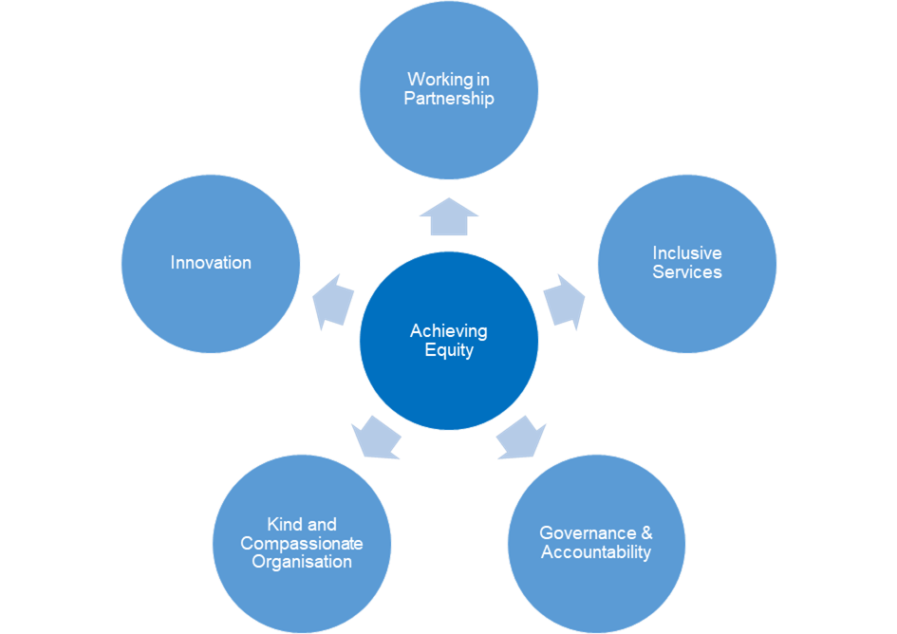

Objective A: Achieving equity by working in partnership - ‘nothing about you, without you’.
This objective underlines our commitment to listening to and working with our partners and population to design and deliver equitable, rights-based healthcare that is sustainable.
Objective B: Achieving equity by providing high quality inclusive services.
This objective underlines our commitment to develop and deliver services at the right time, and in the right environment that is truly accessible, and that will meet individual needs.
Objective C: Achieving equity through Governance and Accountability.
This objective underlines our commitment to doing things transparently with honesty and integrity.
Objective D: Achieving equity by being a kind and compassionate organisation.
This objective underlines our commitment to showing everyone kindness, respect, and dignity that everyone is entitled to.
Objective E: Achieving equity by innovation.
This objective underlines our commitment to continuous learning, innovative practice and approaching new ideas with an open mind.

Governance arrangements

During 2024/25, work has been ongoing to ensure that the equality duty is integrated into governance arrangements within the Health Board. This also includes citing equality considerations within terms of reference for all governance meetings, reference to Equality and Socio-economic Impact Assessments on front committee sheets and where appropriate having a representative from the Equality team.

During the year 2024/25, work has continued to advance equality through the delivery of the first year of the BCUHB Strategic Equality Plan. Progress on this annual plan has been reported and monitored through the Equality and Human Rights Strategic Forum. This reports to People and Culture Committee and reports directly to the Board.

Statutory reporting

In line with the Public Sector Equality duty, BCUHB has published the following:

Strategic Equality Plan

The Equality Objectives set out to deliver in our 4 - year Strategic Equality Plan sets the
foundation for advancing equality across the Health Board. Our Strategic Equality Plan (SEP) for the period 2024/25 was agreed and published in March 2024. The four-year plan is aligned to Regulations 14 and 15 within the Public Sector Equality Duty.

Equality Annual Reports

All BCUHB Equality Annual reports are published on the BCUHB website in line with regulation 16 of public sector equality duty: Wales.
Equality and Human Rights Reports - Betsi Cadwaladr University Health Board
These reports provide progress statements that arise from complying with the specific duties within the permitted timelines set by the Equality and Human Rights Commission. In line with regulation 16, our annual reports include:
- The steps taken to identify and collect relevant information and evidence of our progress
- How the Health Board has used relevant information it holds in complying with the general
- duty and the specific duties
- The progress made in order to fulfil each equality objective
- A statement of the effectiveness of:
  - Arrangements for identifying and collecting relevant information, and
  - Steps taken in order to fulfil each equality objective
  - Employment information that the listed authority has collected

Section 3: Review of the Year 2024/25

Section 3 of our report outlines the progress in the first year of the BCUHB Strategic Equality Plan. This report section will highlight actions from year 1 of the 2024-2028 plan.

Each area of evidence aligns to the corresponding equality objective within the strategic Equality Objective and also aligns to BCUHB Three Year Plan and other Welsh Government Plans.

3.1 Focus on National Plans - linked to objectives

3.1.1 Welsh Government Anti-racism action plan and progress


The Welsh Government Anti-racist Action Plan was published in June 2022 and BCUHB has developed a comprehensive plan to address the health actions.

Within the year 2024/25 progress includes:
- Embedding the Anti-racist Wales Action Plan within the Health Board’s Strategic Equality Objectives
- Expanded diverse representation within the Health Board’s Equality Stakeholder Group.
- Widened Equality and Inclusion training programme to include Active Bystander, Microaggressions and cultural competence.
- Focused support for BCUnity staff network, to grow membership and their wider involvement in Health Board culture and values work
- Undertaken an Integrated Equality Impact Assessment for the plan.
- Developed an action plan following the first Welsh Workforce Race Equality Standards Report

3.1.2 Welsh Government – LGBTQ+ Action Plan
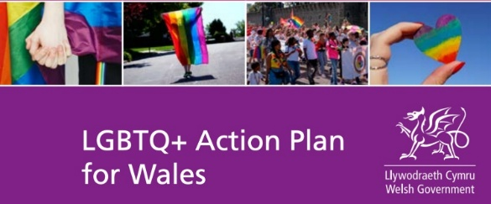
In February 2023, the Welsh Government published the LGBTQ+ Action Plan for Wales and BCUHB has developed a comprehensive plan to address the health actions.

Within the year 2024/25 progress includes:
- Embedding the LGBTQ+ Action Plan within the Health Board’s Strategic Equality Objectives.
- Reviewed Health Board’s GP Equality toolkit with LGBTQ+ plan information
- Attended Community and Pride events.
- Provided specialist training to Sexual Health team on Trans Inclusive Sexual Health.
- Delivered a Community Quilt Project for HIV and AIDS Awareness across north Wales.

3.1.3 Code of Practice on the Delivery of Autism Services
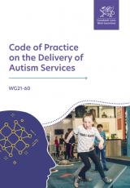
Throughout 2024 work continued to develop a co-produced focused plan of action to improve the Health Board towards compliance with the Code of Practice. With an agreed set of co-production principles and to self-assess on
an annual basis.
- Establishment of Code of Practice Task and Finish Group.
- Development of Action Plan to support the Code of Practice implementation.

3.1.4 All Wales Standards for Accessible Communication

A Sensory Loss and Accessible Health Care information hub was established for staff, which contains sensory loss toolkit guides for Primary Care, Community Services and Secondary Care. The Health Board is represented on the Welsh Government steering group undertaking the review of the standards and expanding their scope to include community language needs and wider areas of accessible communication. See Appendix B for information on the All-Wales Standard for Accessible Communication.

3.1.5 The Health Board’s Three-Year Plan Strategic Objectives 2024-2027

In 2024 the Health Board published its Integrated Three-Year Plan. The Plan marked an important point for the Health Board as it was the first plan developed by the Health Board under the leadership of a new Chair and Chief Executive, supported by a substantial change in Board membership. It signalled a clear ambition to drive through transformation and improvement and provide high quality and sustainable services for the people of North Wales. The plan outlines many of the actions needed to do this and in particular highlights that permanent success requires us to address current challenges with a strong understanding of the needs of the future. With a clear focus on the aims of:

Standardisation
Stabilisation
Sustainabilityy

Recognising the need to prioritise improvements in the areas that led to Special Measures, the core of the Health Board 2024-27 plan builds further upon those five outcome areas and for this report the Health Board’s equality and diversity activities and progress against its action plan has been aligned to the five objectives within the Three-year plan for 2024-2027.

3.1.6 Three Year Plan: Strategic Objectives

During 2023-24 the Health Board continued to make progress against its objectives against the Special Measures framework. As the year has progressed this has coalesced around five main areas where improvement was most necessary. Recognising the need to prioritise improvements in the areas that led to Special Measures, the core of the Health Board 2024-27 plan builds further upon those objectives.

On the following pages are examples of how the Health Board has discharged its equality duty, categorised by the Three-Year Plan’s five strategic objectives are given:

Objective area 1 recognises the importance of governance and effective procedures and decision making in high functioning Healthcare organisations. This will better ensure that decisions are made in a timely way, using appropriate information, and that the right people have been involved to ensure the right decisions are made first time.

2: Developing strategy and long-lasting change
Objective area 2 draws upon the need for the Health Board to be clear about population needs in North Wales and that services are configured in a way to get the highest value from the resources available to us. In this way the Health Board can provide services that are reliable, more cost-effective, and that make the best use of healthcare professionals.

4: Improving quality, outcomes and experience
Objective area 4 covers a large thematic area where improvements are required to improve clinical performance across a number of key areas. The Health Board wishes to build further upon good work commenced that takes a pathway focused approach to this.
3: Creating compassionate culture, leadership, and engagement Objective area 3 capitalises upon the huge body of evidence that demonstrates how culture, leadership and engagement with residents, staff, communities, and partners significantly impact upon the quality of services and patient experience provided. The Health Board has identified opportunities to make improvements in these areas that would then in turn lead to better outcomes.

5: Establishing an effective environment for Learning
Objective area 5 provides opportunity to learn when things don’t go as planned, to teach, and to widely use the many sources of information available to us in order to support decision making and knowledge.


Building an effective organisation

Improving equality monitoring

During 2024/25, work has been underway across BCUHB to improve digital systems to inform intelligence-led planning. A Populational Health Management project has been in place across Public Health and Digital, Data and Technology (DDaT) team.

Outcome

This is enabling data sharing between primary care and secondary care and patient segmentation. Projects are underway during the reporting year to identify data to support improvement of services to those with learning disabilities. Improving equality monitoring as part of routine data collection together with Health Inequalities public health programme. The outcomes of this work will ensure that decisions are evidenced based and will help monitor the impact of preventative and health interventions.

Achieving Equity in Decision Making toolkit
During 2024/25, a new toolkit to support decision makers was produced. This toolkit is called ‘Achieving Equity in Decision Making: A practice toolkit for decision makers and project teams.

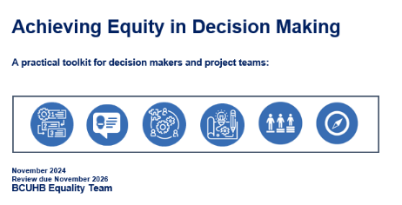
The toolkit was written to advise and support staff involved in delivery of projects and programmes of work that involve making decisions that impact on patients, staff, and our communities. The aim is to ensure an inclusive, rights-based approach is consistently adopted, to improve compliance with statutory duties and to ensure socio-economic, equality and human rights considerations within decisions. This approach will enable the Health Board to demonstrate that decisions have been made in a fair, transparent, and accountable way and have considered the needs and rights of everyone.

Outcome

The outcome of this work helps to ensure that there is compliance with our statutory duty, and also help decision makers to feel more confident in their knowledge of the statutory requirements for a range of different decisions such as:
- Transformation and Improvement plans and proposals
- Procurement and Commissioning processes and decisions
- Financial Decisions
- Business Case Development – each stage of a business case
- Policies, Standard Operating Procedures and Guidance
- Pathways and Strategies

Socio-economic Duty Progress Report and Audit
The Socio-economic Duty (Part 1 to 3 of the Equality Act) commenced 31/03/2021 and places a legal duty on BCUHB to have due regard to the need to reduce the inequalities of outcome resulting from socio-economic disadvantage.

In order to monitor its progress, the Health Board uses the Welsh Government progress tracker. This helps BCUHB self evaluate our level of progress from:

- Getting started: gaining and demonstrating commitment
- Early progress: should be quick and easy to implement. This reflects simple changes that have
- a low risk of failure.
- Firm progress: involves stepping out of a ‘business as usual’ mind-set and acting to change how things are currently done. Signalling early progress to wider change, this might involve a change in process and ways of working.
- Advanced progress: this is a systemic, transformational change to how things have always been done and will require reallocating resources, time to put the changes in place and collaboration with other bodies. Actions are innovative, inspirational, and collaborative; putting the Duty into practice across all portfolios, this way of working becomes embedded in the organisation.

Outcome

Since 2022, BCUHB have completed the annual progress tracker alongside an internal audit of assessments which demonstrates due regard to the duty. This is reported annually to the Equality and Human Rights Strategic Forum. A summary of the self-assessment findings for 2024/25 is as follows:

Organisational process: Considering socio-economic disadvantage and reducing inequality in decision-making/policy development:
Self-assessment finding: Firm progress (3):
- Socio-economic Impact Assessment (SEIAs) are completed for the majority of strategic decisions. Some excellent examples of work undertaken by project managers.
- Additional advice for decision makers through Achieving Equity in Decision Making.
- Wider Local Authority partnership working – Public Health team scrutiny of planning.
- applications to embed health inequality considerations into planning decisions.
Organisational process 2: Accountability and scrutiny: Self-assessment finding: Early progress (2):
- Governance papers include EQIA and SEIA and recent audit work showed that papers for strategic decisions were presented without a socio-economic assessment being completed. (6/8 were completed).
- Board Members have not received any EDI awareness session since Dec 2022 (added to Corporate Risk Strategy) Due to this, unable to check if members are aware of the statutory duty – which may lead to understanding of the duty.

Organisational process 3: Tracking and reporting on impact: Self-assessment finding: Early Progress (2):
- The work of the 3-year plan and work under special measures may help to identify reporting on improvements within the Health Board to tackle long waits and meet demand.
- Significant work is underway informed by population health data and evidence to develop preventative approaches to long term health conditions such as Diabetes.
- Board Members have not received any update on SED reporting since December 2022.

Organisational process 4: Engagement, involvement, and consultation: Self-assessment finding: Firm progress (3):
- Engagement undertaken for key transformational projects. Some projects are still ongoing such as the Royal Alexandra Community Hospital.
- New projects such as new primary care hub hubs have considered the duty.
- New toolkit for decision makers available to help guide programme managers / project leads for different types of decisions on what is required and when aligned to Brown, Bracking and Gunning principles.

Reporting progress ensures that we follow good practice for evidencing our progress towards the Socio-economic Duty.

Accessible Communication Standards Review

The All Wales Accessible Standards for Accessible Communication and Information for People with Sensory loss were initially published in July 2013, making Wales the first country in the UK to lay out how NHS services would be delivered to people who are Deaf, hard of hearing, blind, partially sighted or have dual sensory loss. The Standards set out the level of service delivery that people with sensory loss should expect to be met with when they need healthcare.

In October 2023, the Minister for Health and Social Services approved the recommendations to broaden and renew the All-Wales Standards for Accessible Communication and Information for People with Sensory Loss to include community languages and wider communication needs.

During 2024/25 the Health Board was part of the all-Wales working group focused on developing the new standards.

Outcomes
- 31 new objectives were identified
- Progress on the development of the Standards were provided to the Health Board’s Patient and Carer Experience Group
- The Health Board secured funding to pilot video relay service (VRS) and video relay interpreting (VRI)
- Establishment of a BCUHB Task and Finish group to support the implementation of the revised standards when they are finalised and published.

Developing a strategy and long-lasting change

Vaccine Programme
The Health Board continued to deliver its Strategic Immunisations Plan 2023-2026, “Leaving Nobody Behind”. The Strategy fully commits to a proactive approach to reducing health inequality by reducing the vaccine equity gap. Evidence shows a persistent and significantly lower uptake amongst Black, Asian, Mixed, and other ethnic groups compared with combined White ethnic groups, and amongst more socio-economically deprived communities compared to those who are more affluent.
The key equality themes around which the strategy is built are:

- Optimising how we collect, collate, and use intelligence regarding vaccine equity
- Value of identifying and working through existing trusted networks and leaders
- Draw learning from national equality work, and proactively share best practice
- Regularly review equality impacts and respond to findings in a timely way
- Communications to support access to information in accessible formats.

The MMR (Measles, Mumps and Rubella) Vaccination Programme is currently
offered at 12 months (first dose) and 3 years 4 months (second dose) of age. With
the forthcoming implementation of the childhood schedule changes (WHC/2025/019),
from 1 January 2025 the second dose of MMR will be offered at a new and earlier
18-month appointment. This is following recommendation by the Joint Committee on Vaccination and Immunisation (JCVI) to improve coverage and reduce the likelihood of measles outbreaks.

Significant emphasis has been placed on:
- Targeted engagement with Gypsy, Romany, and Traveller communities,
- addressing vaccine hesitancy through trusted health professionals. This
- reflects a co-productive, community-based approach to public health,
- aligned with the principle of ‘nothing about you without you.’
- Clinical updates for frontline staff i.e., nurses, GP’s and school nurses aim.
- to improve vaccination literacy and ensure inclusive service delivery.
- Disaggregated uptake data by age, geography, and educational setting,
- providing a baseline and supporting data-driven planning
- An emphasis on supporting trusted professionals to engage with hesitant communities.
- with a compassionate, culturally sensitive approach. This work fosters trust and dignity,
- especially in communities with previous mistrust of public services.

The impact can be seen in the overall improving uptake rates in North Wales,
and as we develop our disaggregated, data-driven approach to vaccine equity
we are confident we will be able to evidence this in the coming years.

Reducing Homelessness

During 2024/25, the Health Board undertook work to prepare for new legislation with a duty to ‘ask and act’ to identify (including referral) patients at risk or experiencing homelessness and signpost to support.

During 2024, co-production work had been underway to improve information about the needs of people at risk of, or experiencing homelessness. This also included wellbeing advice and information for staff who were facing eviction and risk of becoming homeless. During this work, Welsh Government published a consultation on the Draft Welsh Government Ending Homelessness Legislation.

In preparation for the new requirements, the Homelessness Reduction Implementation Group was established. This group has a small but growing membership of individuals who care passionately about preventing homelessness and supporting people who face homelessness.

Working in partnership with homeless support organisations and BCUHB teams, the group works together with the recognition that preventing homelessness is everyone's business, not just the role of housing organisations. Homelessness and health are deeply interconnected and requires a whole-system approach to address the factors that influence homelessness.

Outcomes

The first steps of this group have been engaging and improving links with Homelessness Teams to improve patient outcomes, reduce healthcare costs, improve housing outcomes, and enhance collaboration between services. Initial work has been undertaken which have mapped the experiences of support workers within homelessness teams across each of the local authority areas.

This has identified a number of priority areas which relate to safe discharge processes and improving timing of communications and identification of housing needs with partner homeless teams.

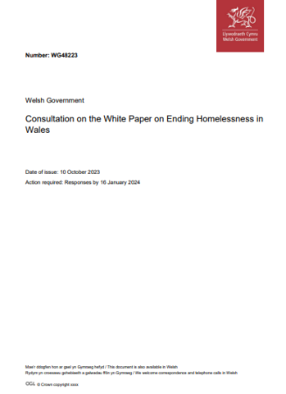
Alongside this work, engagement is taking place with people who have lived experience of homelessness. BCUHB are working with The Wallich, My Home Denbighshire, and Shelter, to carry out engagement to ensure that patient experiences of health are involved in this work on the principle of “nothing about you, without you”.
This work has received interest and support from Welsh Government, as they look to how health organisations can implement the new legislative requirements.

Childrens Rights Charter
Significant work has taken place during the year 2024/25 to ensure that Children’s Rights were promoted across BCUHB. The charter was presented by a group of young people to theBoard in September 2024.
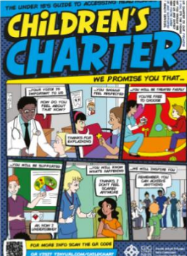
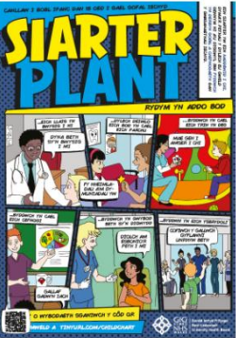

The Charter is the BCUHB promise to children and young people with all the care and support that children and young people should expect when they receive health services.
The Charter has been widely shared across the Health Board and is informing decisions to ensure that services are inclusive and meet the needs of children and young people.

Equality Roadshows
As part of the Health Board’s commitment to engagement and openness, the equality team held a series of 17 roadshows during Oct-Nov 2024, visiting the main hospital sites as well as community hospitals and Health Board buildings engaging with staff, patients and the wider public. The roadshows were an opportunity to share the progress that the Health Board had made against its Strategic Equality Objectives, identify new actions for the second year of the action plan from feedback. Provide inclusive and accessible information and resources to staff, patients and the public and increase the membership of the Health Board’s staff networks and equality champions.

Outcome
- An additional five new actions were identified and included in the second year of the Strategic Equality Plan.
- Membership of staff networks and equality champions program increased by over 50 new members. Network members were then invited to be Culture Champions within the Health Board.
- Increased awareness led to increased requests for the equality team to support several Health Board projects around Equality Impact Assessments as well as be involved in strategic planning groups for key Health Board projects.

Transformation projects

Nuclear Medicine Consolidation Programme
Equality considerations are demonstrably informing major change project in healthcare in North Wales. The Nuclear Medicine Outline Business Case and options appraisal was fully informed by a robust Integrated Equality Assessment. This approach included assessing each option within the case against the current inequalities recognised within the system and scored the options on their ability and likelihood to remove or reduce those inequalities.

Using the Integrated Equality Impact Assessment in this way, the appraisal was able
to assess the ability of each option to address issues such as the impact of access to transport for populations more likely to be in need of services, the accessibility issues faced by the current service model, the impact of longer waiting on populations living with multiple co-morbidities, the ability of the service to meet the cultural and linguistic needs of populations, the intersectional needs of an ageing population, and the diverse needs of the whole north Wales population by geography.
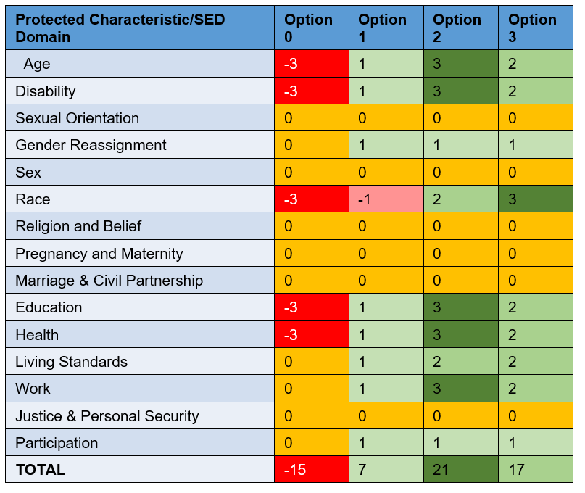
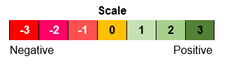

North Wales Medical School
The Health Board used a similar model in the assessment of the North Wales Medical School business case. This allowed the decision on the preferred option to be informed by the various options’ ability to address issues such as issues with the physical estate and accessibility from a physical, sensory, and neurodivergent perspective, the perspective of different populations’ access to education and work opportunities, and the resulting effect of options on clinical spaces and service provision.

Human Immunodeficiency Virus (HIV) Strategy (Including Quilt project)

Welsh Government published its HIV Action Plan for Wales in 2023. The plan has a three-year focus, and has five priority areas for action:
    - Prevention
    - Testing
    - Clinical Care
    - Living well with HIV
    - Tackling HIV-related stigma

These actions will be underpinned by three core principles:
- There should be zero tolerance of HIV-related stigma
- That plans for implementation of new initiatives and services will be informed by, or developed with, people living with HIV. Alongside this there will be a recognition of contextual differences by sexuality, ethnicity, age, gender, and location, to ensure that no one is left behind. Services will take into account the needs of Welsh speakers.
- All new initiatives and services will be subject to ongoing monitoring and evaluation to make sure they meet the actions and principles laid out in the plan. Actions taken in Wales will be guided by the evidence base, and research in sexual health and HIV will be optimised and overseen by PHW and the research network from Welsh universities.
In December 2023 the Health Board was part of a network that committed to be a ‘Fast Track’ region, with the creation of Fast Track North Wales.

Fast Track Cymru is a network of Fast Track Cities across Wales working to collectively reach the UNAIDS targets in all Welsh cities, towns and seven Welsh local Health Boards. It is currently funded to March 2025 by the Welsh Government and employs four staff: a Manager and three part time Development Workers who support the local collaborations. It is hosted by Pride Cymru and has an Advisory Council which includes key stakeholders from across Wales.

At present Fast Track Cymru has four active regions – Cardiff & Vale, Newport, Swansea Bay, and North Wales (covering the BCUHB Health Board area).

The priority areas and core principles of the action plan have been incorporated into the Health Board’s Sexual Safety Strategy.

Outcome
- Adoption of strategies to eradicate new HIV transmissions and prevent late diagnosis via campaigns such as;
  - HIV Testing Week
  - SEXtember – seminar sessions and testing promotion
  - Providing community testing kits at engagement events such as Pride, Student Freshers week and as part of the Health Board’s community quilt project
- During 2024 the Health Board’s community quilt project held a total of 22 community quilting sessions. These included 11 public sessions, 3 patient focused sessions and 8 sessions with community groups representing LGBTQ+, learning disability, faith and young people. Over 135 quilting squares were completed. These were used to make a total of three quilts, one for the each of the sexual health teams in the Health Board. The completed quilts were shown at the World AIDS Day event, supported by Bangor University who as part of the project undertook attitudinal surveys during the last three months of the project with workshop participants.
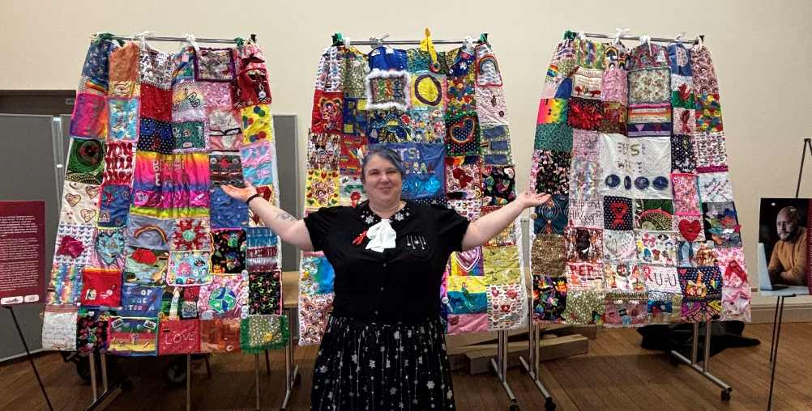


Creating compassionate culture, leadership, and engagement

Widening Access

The Health Board Widening Access programmes offer systematic opportunities for a range of people with barriers to recruitment, including those who are furthest from the labour market, young people, those in Black and Minority Ethnic groups, evacuees, long-term unemployment, in work poverty, with a learning disability, neurodivergent and or disability.

- Apprentices
- Supported Shared Apprentices
- Supported Internships
- Adult Volunteer Programme in partnership with Social Care

Providing sustainable employment for young people through clear apprenticeship pathways and post-apprenticeship roles, alongside access to professional education and training, is essential to building and maintaining a resilient and future-ready workforce

The Health Board is committed to improving employability for individuals who are often furthest from the labour market. Through structured work placements, skills development initiatives, and tailored support, the Board is helping economically inactive and unemployed adults—many of whom face complex barriers to employment—gain meaningful access to the workforce. This work is delivered in partnership with key stakeholders, including service managers, workforce planning leads, and education providers.
Evidence to date highlights the positive impact of the Widening Access programmes across all areas of work. Efforts will continue to strengthen and refine these pathways to ensure long-term sustainability and inclusive workforce development.

Project SEARCH/Supported Internships
In this scheme, interns with learning disability, neurodivergent and or disability are with BCUHB for a whole academic year, giving real work skills and experience in roles such as pharmacy technician, health care assistant, housekeeper, estates, administration, and facilities services.

With onsite tutor and job coaches, the interns undertake classroom instruction, career exploration, and on-the-job training and support.

BCUHB work in partnership with the intern, parents/carers, local authorities, Project SEARCH, local colleges, supported employment agencies and colleagues across the Health Board.

The target outcome is to provide jobs in BCUHB or the local community, as less than 10% of these young adults in the UK are in employment of over 16 hours per week. 70% of the participants of BCUHB programmes are in employment of over 16 hours per week.

BCUHB currently has three sites involved in partnership projects:

- Glan Clwyd Hospital
- Flintshire Community
- Ysbyty Gwynedd Hospital
Work is now ongoing to implement a programme in Wrexham Maelor Hospital.

Supported Shared Apprentices
This scheme is delivered under the Welsh Government Work Based Learning programme. The purpose of the scheme is to support the apprenticeship agenda by widening access to individuals aged 16+ who cannot (because of key skill requirements and/or reasons of disadvantage) partake in a mainstream apprenticeship.
Apprentices are employed by Agoriad Cyf, who are a supported employment provider. The apprentice is placed with BCUHB (the host employer) for the duration of their training. A job coach is supplied for the duration of the apprenticeship.
Nine supported interns to date have secured Supported Shared Apprentice posts, working as health care assistants, porters, domestics, and housekeepers. Happily, to date, two have completed the scheme and been recruited to BCU as health care assistants.

Five previous interns have been employed as apprentices using the previous pathway.

Apprenticeships
In response to the Apprenticeship Levy, and with the joint aims of supporting BCUHB in addressing recruitment challenges as well as supporting young adults in the community in to work, work is ongoing to increase apprenticeship uptake in BCUHB.

- 10 HCA apprentices in Ysbyty Glan Clwyd completing a Level 2, 5 have securing permanent roles in BCUHB and moved onto their Level 3. The remaining 5 are progressing well.
- 6 Finance apprentices, Levels 2, 3,4. One Level 4 apprentice has completed the apprenticeship the secured a substantive position.
- 2 Engineering apprentices have completed the Level 3 Framework and secured substantive positions both have progressed to Level 4 Framework. 4 Apprentices working towards the L3 framework.
- 5 IT Degree apprentices completing year 2 of the apprenticeship on track to achieve Degree 2026
- Primary Care Activity Report apprentice completed Level 2 secured a position and progressed to Level 3.
- 20 Pharmacy Apprentices.
- 200 substantive staff are following 17 different apprentice routes.
BCUHB/Social Care Adult Volunteer Programme
The adult volunteer programme in BCUHB incorporates initiatives from groups who face barriers to recruitment, including those who are furthest from the labour market; young people, those in Black and Minority Ethnic groups, evacuees, people in long-term unemployment, people in work poverty, people with a learning disability, neurodivergent individuals, and people with a disability.

Bi-monthly mentoring circles are held throughout the year, providing opportunities to make connections, build trust and confidence, learn about the Health Board and Social Care, coaching on how to apply for NHS Jobs, Interview Skills, Mock Interviews and Health Board induction information.
Participants are supported and trained for the role they are interested in, including all mandatory training, DBS, and Occupational Health Clearance. Participants will complete a 6-week unpaid placement of a minimum 16 hours per week.
If successfully on placement, workforce policy allows for direct recruitment to bank, fixed term, or apprenticeships. Participants benefit from guaranteed interviews for jobs where they meet the essential criteria.
The programme provides continual evaluation and updates/coaching for participants, from social enterprise partners and the work placement areas.

Outcome
Many of the programmes’ participants would usually find it difficult to apply for posts and gain employment through traditional methods, due to recruitment barriers such as large employment gaps, no work references, no transferable experiences, lack of confidence, lack of experience or knowledge of job applications, lack of interview skills, disability, or in work poverty. The programmes have facilitated a process that removes barriers to recruitment so that participants can be supported into work.

Feedback from participants is that they feel valued, part of the team, confident and excited to begin new careers in the NHS, and to date, across all Widening Access programmes in BCUHB, 498 job opportunities have been secured in bank, fixed term, apprenticeships, permanent posts, and external posts as a direct result of completing the programme.

Evidence now shows that whole communities and extended family members are following the Widening Access journey as the programmes have established. The Widening Access offer is now a sustainable set of programmes that encourages and supports individuals into careers in BCUHB.

Spiritual care

At the heart of chaplaincy is the aim to meet the diverse spiritual/religious needs of patients, visitors, and staff. Key to meeting that need is having a wide, vibrant relationship with those communities/groups within the North Wales area. Such relationships enhance service provided and our engagement and joint working has benefits way beyond the spiritual. Closer working and understanding each other's history and culture benefit all patients enabling our staff and patients to receive more culturally competent care. It also enhances the longevity that people stay in the area to work - if they feel this is their home.

Example of Cultural Engagement

The Indian Kerala community has recently become a major part of the life of the hospital and wider community - especially within nursing. The chaplaincy is at the heart of this community – which is predominately Christian catholic, orthodox and Church of South India (CSI). The chaplaincy service attends and participates in all their main gatherings and festivals. This has brought benefit to both the community and the Health Board, as up to 400 staff and their families attend these events. The Chaplaincy also attends cultural events in the community, such as the Onam Celebration (Indian).

This culturally inclusive approach provides the Health Board with a living relationship with communities surrounding our hospitals and also provides the chaplaincy a relationship with a community within the broader staff population that can be called upon in time of need.

Outcome

- The Chaplaincy have developed a daily proactive relationship with the Indian community in north Wales. This brings benefit for the Kerala community, those who choose to live and work in north Wales and enhances the quality of care that they deliver to the wider population.
- The Health Board have also attempted to integrate their culture and practices into the daily life of the Health Board, for example cultural celebrations are held across Health Board sites such as Dancers and choirs at Christmas and within community events. This includes the establishment of a Kerala dance and music group.

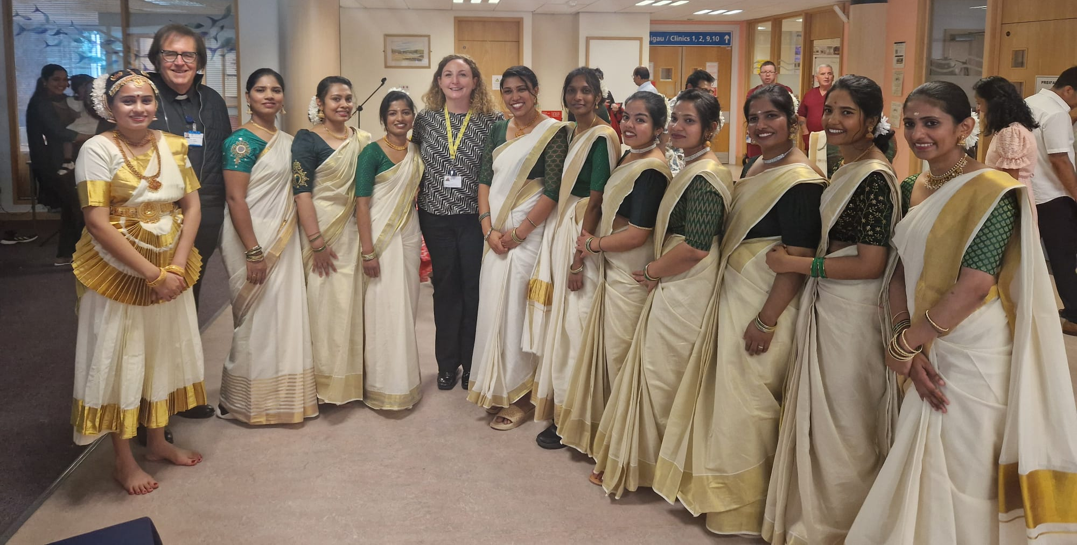

Armed Forces Community

During 2024/25, the Health Board has continued to promote awareness of the armed forces community and ensure compliance to the Armed Forces Act 2021 requirements to enshrine the Armed Forces Covenant. The Health Board has established the North Wales Veteran Healthcare Collaborative (NWVHC) to improve NHS care for the Armed Forces community across North Wales. The work is coordinated by the BCUHB Veterans Lead, who is part of the Armed Forces Community. During 2024/25, this work has included raising awareness of the Armed Forces Community though:

- Establishing a dedicated information hub for all staff outlining available support for the Armed Forces community to ensure they are not disadvantaged in terms of access to healthcare. They have also communicated a wealth of information to the patient population of North Wales about accessing appropriate Veteran healthcare services.
- Promoting the Poppy veteran identification programme
- Achieving reaccreditation of the Veteran Aware Accreditation as part of the Veteran Healthcare Collaborative (VCA)
- Continuation of the Veterans’ staff network and recruitment processes which guarantee interviews for veterans who meet the criteria.
- Remembrance Services held 11th November 2024 across the three main sites with the Wrexham Wellbeing Choir recording a special performance of The Rose.
- Support the Fighting with Pride Military Charity and campaigns.

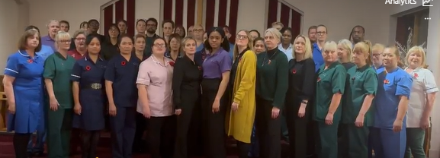

Photo showing The Wrexham Wellbeing Choir

Campaigns and Awareness Days

The Equality Team work closely with our staff network members and divisions of the health Board on many health campaigns and Awareness days, including cultural festivals. The aims of this work is to increase understanding of diversity, enhance cultural competence and to increase visibility within the Health Board.

Celebrating Spring and Culture at Betsi Cadwaladr University Health Board (Event)

In April 2024, the Llanberis Community Hall in Llanberis, Caernarfon, Gwynedd, Wales, was the venue for a celebration. Health Board colleagues gathered to celebrate the spring Indian New Year, creating a vibrant and welcoming atmosphere. This annual event was part of a series of initiatives designed to promote staff and family well-being. Events such as these foster connections with local ethnic cultures, particularly for staff members from the South Asian community.

This event was attended by 70 people, a mix of colleagues and their families. This was an opportunity for staff members to chat, share stories, and celebrate the arrival of spring together with authentic Indian cuisine. It was a time to appreciate the cultural richness within the Health Board community.

This event serves as a shining example of the Board's commitment to fostering a diverse and inclusive workplace. By celebrating the spring Indian New Year, the Board acknowledges and values the cultural backgrounds of its staff. It demonstrates a belief that a workplace that embraces cultural diversity is a more positive and supportive environment for all employees.

Outcome

Staff feel better informed, have a greater understanding of inclusion and what that looks like and aligns to the Health Board’s values of Compassion, Openness and Respect. Staff have fed back via the NHS Staff Survey, Health Board intranet pages and via the staff networks that they feel a greater sense of belonging via these campaigns and awareness areas of work.

Workforce Race Equality Standards (WRES) Report
In June 2024, the Health Board received its first report from Welsh Government as part of the Welsh introduction to the Workforce Race Equality Standards. The standards review the data on ethnicity held on Electric Staff Record (ESR) as well as information garnered by the NHS Wales Staff Survey and benchmark it against the NHS Wales Averages. This highlights recommendations for improvements that need to be made.

The Health Board’s first report highlighted recommendations on declaration rates on ESR. In January 2025, supported by payslip awareness messages, there was a targeted campaign to encourage staff to update their equality data on ESR. The campaign was led by Chief Executive, who set out why this information was so important to enable the Health Board to get a better understanding of where support is needed as well as strategic changes needed to break down the systemic barriers that ethnic minority people face in recruitment and retention in the Health Board.

Outcome
Recognising that it will take time to see significant changes in Health Board data, there has been a small improvement in declaration numbers between Jan-March 2025. Further improvement is hoped within the next WRES report expected in June 2025.
Living Well, Working Well Handbook
During 2023, focus groups and discussions were held with staff across BCUHB who reflected on a number of questions on themes including: commitment, motivation, behaviour, and structure.

Staff wellbeing was an area of work which staff identified as needing improving, staff understood there were wellbeing resources on the Intranet but had difficulty in finding them. A ‘one stop’ handbook of links to wellbeing resources available to staff including on physical, mental, spiritual, and financial wellbeing and support on working life in general has been co-designed with subject matter experts to support this.

The Living Well, Working Well Handbook is a comprehensive guide to the wide range of health and wellbeing support available to BCUHB staff. Designed to be user-friendly and interactive, this resource helps staff quickly find the tools, services, and information they may need, both within BCU and from trusted external sources.

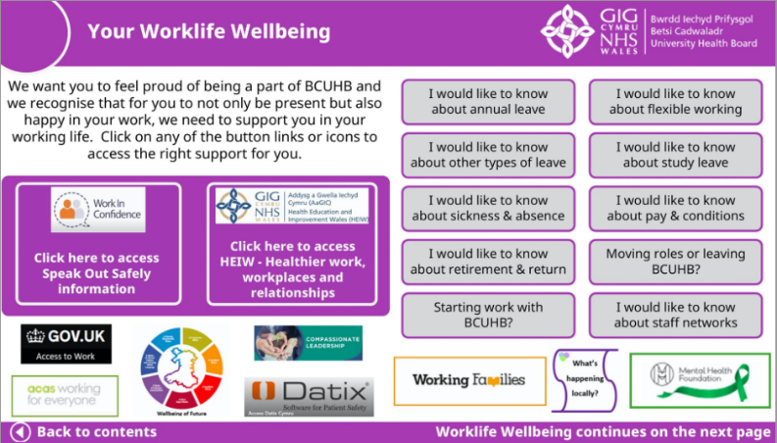
The handbook is designed to enhance our colleague’s day-to-day experience at work or support their overall wellbeing, the handbook is organised into the following key areas:

- Work life Wellbeing
- Physical Wellbeing
- Mental Wellbeing
- Spiritual and Pastoral Wellbeing
- Equalities Wellbeing
- Financial Wellbeing

The Handbook was collaboratively developed by staff and trade union representatives, and it was piloted by volunteers from various departments across the Health Board.

The name of the handbook was selected by the staff who participated in the testing phase.

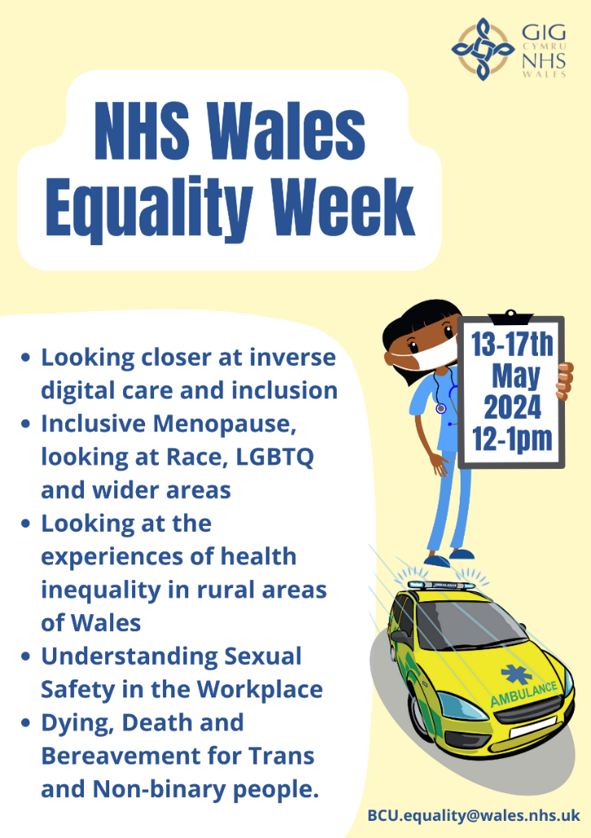
NHS Equality Week 2024
In May each year, the equality leads from Welsh NHS Organisations, come together to hold a series of workshops in May, focused on equality information and health inequalities.

These sessions are the start of conversations and are aimed for NHS Wales staff to learn and embed best practice in their own areas of work to improve the experiences of both staff, patients, and the wider community. Each session is recorded and is a resource for further awareness within the Health Board. The themes for 2024 were:
- Inverse Digital Care and Inclusion
- Inclusive Menopause
- Health Inequalities in rural areas of Wales
- Sexual Safety in the Workplace
- Death, Dying and Bereavement for Trans and Non-binary people

Outcome

- Over 1500 NHS Wales staff attended the live sessions with the videos as learning resources
- Project established regarding the mapping of Digital Inclusion needs and resources.
- The Health Board has led on the development of the All-Wales Sexual Safety Policy.
- Trans inclusive bereavement needs were included in the bereavement workstreams conversations following the session.

Toolkit - Best Practice for Making Health and Social Care Provision LGBTIQ+
Age Friendly

During 2024/25, a co-produced toolkit was produced between teams across the Health Board and with Unique and other LGBTQ+ organisations working across north Wales. The aims the toolkit is to provide staff with 10 tips for good practice that ensures everyone is treated with dignity and respect.

Since the publication of the toolkit, a training session has been delivered to care home staff across north Wales. Feedback on the toolkit highlights that staff can make a significant difference by their knowledge, attitudes, and behaviour towards LGBTIQ+ people. This can have a profound, beneficial effect on an individual’s health and wellbeing and also influences the attitudes and behaviour of other colleagues and service users. The toolkit has also been an action within the BCUHB LGBTQ+ action plan to help raise awareness of the needs of older LGBTQ+ people.
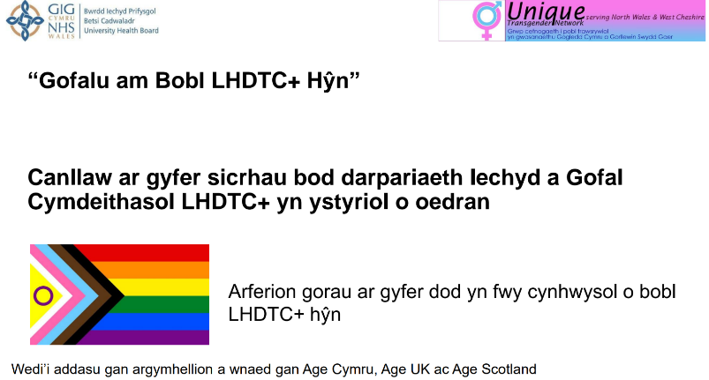
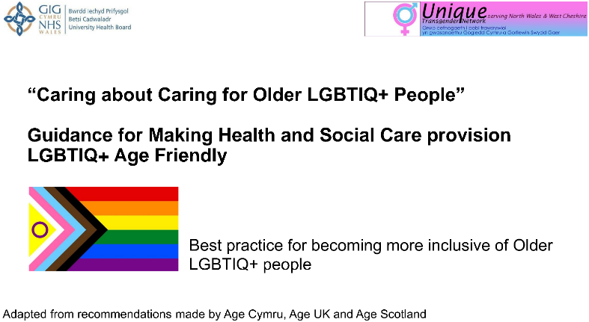

Financial Support for Staff
Throughout 2024 and into 2025, the staff wellbeing team, in partnership with colleagues across the Health Board continued to ensure that up to date guidance and support for staff facing financial hardship was available via our staff wellbeing service and the BCUHB intranet.
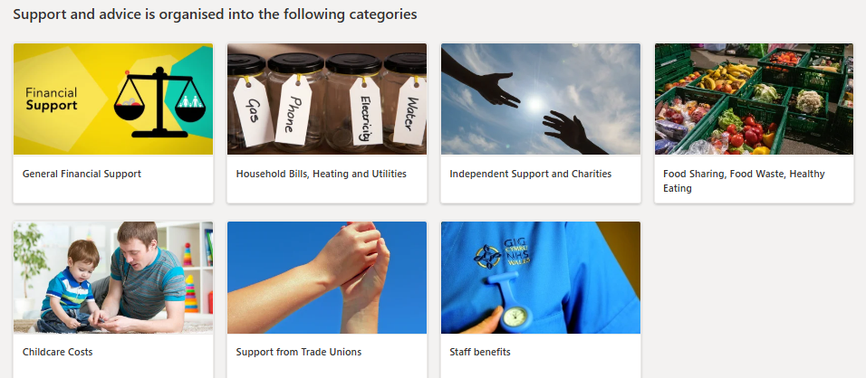

LGBTQ+ Compassionate Care
One of the resources developed and used during training to demonstrate what compassionate, inclusive care looks like is Am Byth, a short film is based on the true story of a lesbian couple, Kim, and Roseann, who were married at Velindre Hospital, Cardiff in 2018 whilst Kim was receiving treatment for cancer. This emotional film is a touching love story between two women and is also a celebration of the amazing staff who work for our NHS and the importance of compassionate care.

The film was made in English and Welsh, with the English Version. I Shall Be Whiter Than Snow, been shown all across the UK as part of Iris on the Move and was selected to feature at Roze Filmdagen - the Amsterdam LGBTQ Film Festival.

One of the key areas regarding the film, was that it was written, directed and included NHS staff in the film roles.

During 2024-25, the film was incorporated in several LGBTQ+ partnership events in North Wales that focused on coproduction of the health boards LGBTQ+ Action plan.

Speaking about the collaboration between Iris in the Community and the NHS, Ceri Harris BEM, Head of Equality and Human Rights, said: “I was so honoured to bring Kim and Roseann’s love and story to screen. Working in partnership with Iris on this film has been wonderful. Iris understood how important it was to tell their story, to share the amazing compassionate care they received. I will be eternally thankful to Iris.”

Sexual Safety
The Worker Protection (Amendment of Equality Act 2010) Act 2023 came into effect in October 2024. The main focus of the Act is to place a responsibility on employers to take reasonable steps to prevent sexual harassment of their employees in the workplace.
In anticipation of the duty, the equality team led the formation of a task and finish group in in February 2024. The purpose of the group was to review the current approach and identify further actions to be taken to ensure that the organisational approach ensures a preventative stance and moves away from the more traditional (primarily) ‘zero tolerance’ attitude that may be seen as taking action after the fact.
A comprehensive approach was adopted that included awareness raising, culture change, policy and guidance development, intelligence gathering, support provision, confidence raising and trauma support.
It was recognised that any processes, tools, training, and guidance that was developed as a result of the task and finish group’s work must be accessible to a wide range of people – from someone who may have suffered a traumatic incident of sexual harassment to those who are using it as a reference document when managing a case.
The sexual safety project developed the following workstreams:
- Inclusion of sexual safety principles in new starter orientation materials, staff handbook and mandatory training hard copy booklets
- Inclusion of principles in the Integrated Learning Development Framework management training
- Develop suitable bilingual posters for circulation
- Include sexual harassment reporting routes and counselling services in staff wellbeing guidance
- BCUHB Intranet sexual harassment resource and guidance page created
- Payslip messaging utilised for awareness raising
- Anonymous concern raising platform Speaking Up Safely now tags cases to enable high level case tracking
- Overall Data development/collection – opportunities continue to be explored to gather this data to widen the scope of available data to demonstrate the current situation in BCUHB.
- Awareness raising sessions were developed in partnership with Welsh Women’s Aid and are now held every 8 weeks on a rolling basis.
- An anti-sexual harassment policy has been developed to provide specific guidance and training around workplace sexual safety and the process to be followed in the event of a disclosure, report or witnessed incident.

BCUHB colleagues have been involved in developing all-Wales workstreams:
- Creation of an All-Wales Policy for the Prevention of Sexual Harassment
- Creation of one initial assessment form
- Creation of the learning plan for All Wales Spotlight Sessions
- Creation of an All-Wales Sexual Safety Risk Assessment
- Develop Sexual Safety Charter and Principles for Wales
- Creation of a Communications and Engagement Strategy
- Introduction of an anonymous reporting system
- Creation of an E-Learning Module
- Development of effective reporting/data collection of sexual harassment cases
- Development of an All-Wales Risk Assessment:
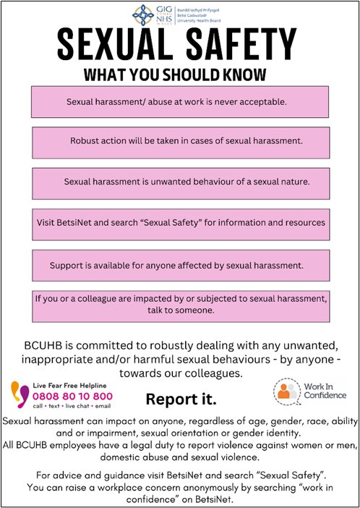
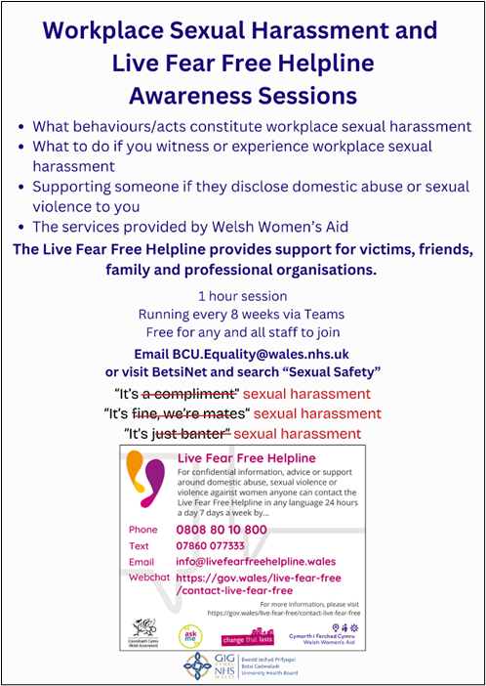

Gwella Modules
As part of a review of the Health Education and Improvement Wales (HEIW) Integrated Leadership Development Framework, the BCUHB equality team worked with the Organisational Development team to develop two core modules to be available via the HEIW Gwella learning and development platform.
These modules are:
Achieving equity through good leadership practices, and Neurodiversity Awareness
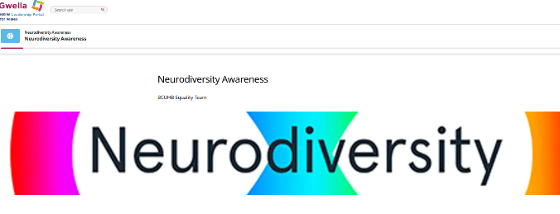
These modules are now available as self-directed online learning for colleagues to access and complete as part of the HEIW leadership framework.
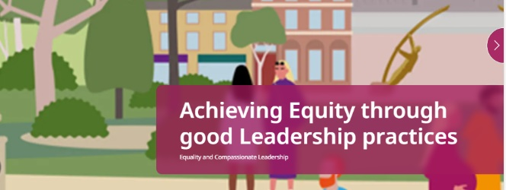
Induction Review - Compassion Video
In partnership with HEIW, the Health Board has developed a video resource that can be shared across Wales to support staff in all health and care settings. This video is available to all partner organisations to support staff at all levels to develop greater understanding and increased demonstration of compassion and empathy, not only to provide improved patient care, but to improve staff relationships and overall organisational learning and culture.

The new resource supports the aims of both BCUHB and HEIW in delivering work in support of A Healthier Wales: Our Workforce Strategy for Health and Social Care Workforce and, most recently, the National Workforce Implementation Plan: Addressing NHS Wales Workforce Challenges in reinforcing A Healthier Wales’ central focus on workforce wellbeing and its ambition to build compassionate, collective and inclusive cultures as a sustainable foundation for robust strategies to attract, recruit and retain talented people to train, work and live in Wales.
This resource contributes to the following project objectives:
- To have a workforce with the right values, behaviours, knowledge and skills
- To have a workforce that feels valued and is valued.
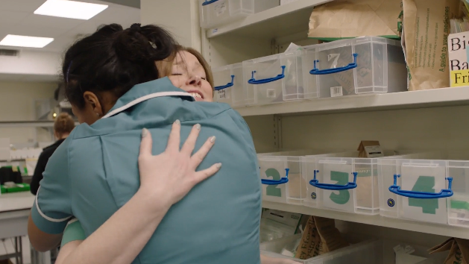

Health Board’s First Race Pay Audit
As part of our commitment to adopting to an anti-racist approach to our delivery of service and developing and supporting our workforce, in 2024 the Health Board developed a race pay gap report. By commencing work in this area, we will start to gain insights of the difference in average hourly pay between different groups (disaggregated by ethnicity) across the workforce. From April 2024 BCUHB has been required to implement the Wales Workforce Race Equality Standards (WRES). The WRES is a tool which will be used to capture evidence of the workforce experience at a national and organisational level. It will enable workforce data to be consistently scrutinised against common indicators grouped under four domains:

- Leadership & Progression,
- Continuous Professional Development & Training;
- Discipline & Capability;
- Bullying, Harassment and Discrimination.

It will highlight where there are disparities in the experience of Black, Asian, and Minority Ethnic health and social care staff. By doing this it will support organisations to implement targeted action to address systemic issues to improve the experiences of the Ethnic Minority workforce. Improving workforce experience for Ethnic Minority staff will improve the experience of all staff, and in turn that will improve patient and public outcomes, supporting the quadruple aims of A Healthier Wales: Our Plan for Health and Social Care.

By producing an annual race pay gap report we will have a more complete picture of our employee experience, which will inform the actions to address and improve the organisations WRES results.

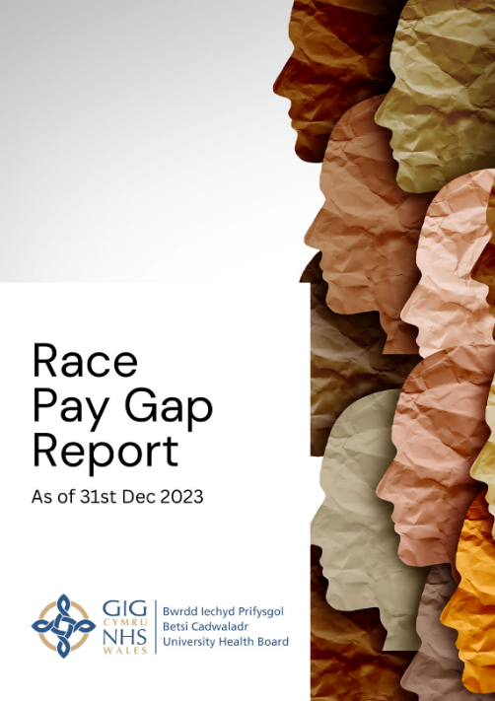

Improving quality, outcomes, and experience

Code of Practice for Autism Services
The Health Board has developed a co-productive approach to working in compliance with the Welsh Government Code of Practice for Autism Services. During quarter 4 a clinical lead was appointed to oversee the delivery of the action plan. Work has been undertaken by the Neurodevelopmental Service pathway group to review pathways against recommendations, and a paper on the Future Model of the Neurodivergent Pathway has been written.

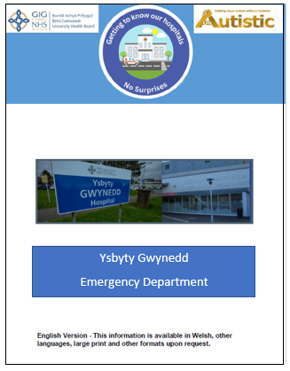
In partnership with Autistic UK, we have been working to develop a series of guides to our sites and services that will be available to all visitors to reduce the anxiety that the unknown environments of a hospital can bring. This is a response to evidence provided by Autistic UK that neurodivergent people in particular are affected by the anxiety that a hospital visit can bring. Our first guide – to the Emergency Department in Ysbyty Gwynedd – was published
in March 2025. The guide contains information on the layout, environment, facilities, and people you might encounter as well as tips for preparing for a hospital visit.

The Emergency Department in Ysbyty Gwynedd has also been working to make the department more inclusive of neurodivergent people.

Staff have undertaken training via the autism acceptance scheme.
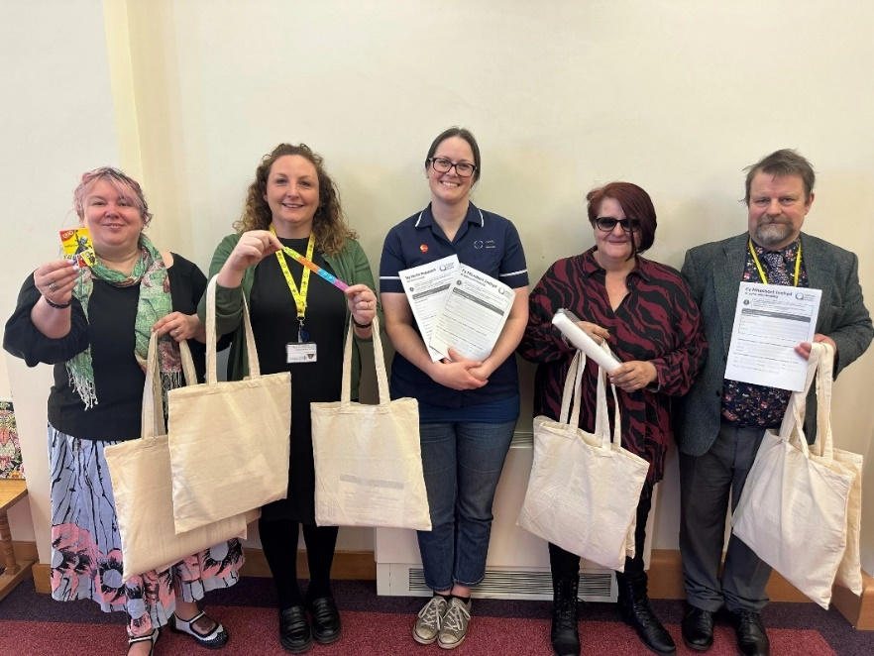
A nurse-led project has created a resource of ‘Busy Bags’ for the Urgent Care departments. These bags contain colouring resources, fidget toys and ear plugs to support children waiting in Urgent Care.

In addition, there are resources such as a portable sensory room box and a pictorial communication book for patients and we have multiple sensory lights around the department.
Feedback has been extremely positive from both patients and staff. The sensory lights have helped with neurodivergent and neurotypical children, and just by staff’s knowledge, has had an overall positive impact on this cohort of patients.

Young People Alcohol Support

An innovative project led by the Public Health team working with the Children & Young People Drug and Alcohol services across North Wales has gathered the views and experiences of the service and opportunities for improvement. A project between the Public Health Directorate, the Health Board& the Children and Young People Drug and Alcohol teams (CYPDAT) across North Wales led to the co-production of a survey for young people currently accessing the services.

Service leads from the CYPDAT engaged with their team members to promote completion of the bilingual survey, accessed via a QR code. The survey was completed by 45 young people and key insights were gained on the use of drugs and alcohol to cope with emotions and fears, and the importance of continued education about drugs and alcohol tailored to different needs. The services were praised for their non-judgmental approach, relationship building and their flexibility in responding to need. The final report was presented to the Children & Young People Area Planning Board with recommendations on how service provision and accessibility could be further improved.

Outcome

Recommendations provided in the report will be presented to the relevant Children and Young People Area Planning Board group for consideration.

Creative Well is the public facing name for the Arts in Health programme at BCUHB.
Arts in Health (also known as Creative Health) supports: -
- Working in partnership to deliver projects.
- Being a kind and compassionate organisation in offering creative activities and targeted activity to groups who may gain the most benefit.
- Delivering inclusive services, through ensuring equity of access to the arts by focusing on the most in need.
- Delivering innovation in the rapidly expanding areas of arts in health approaches, by targeting biosocial models to improve health and wellbeing, and using evaluation to evidence and understand what is being delivered.
- Providing governance and accountability for the Arts, Health and Wellbeing Strategic Framework which includes a clear focus on mental health and wellbeing, and vulnerable groups, using the five ways to wellbeing.
In September 2024, the Health Board approved the Arts in Health strategic framework, which centred mental health and wellbeing, alongside vulnerable groups, nature, and physical activity, as the focus. At the heart of the framework is health inequalities and the five ways to wellbeing, to ensure that those who are most in need can gain the most benefit from engaging in the arts.
The Health Board has several projects underway, including its Arts and Minds work at Tŷ Llywelyn, which supports men's mental health. Many of these men have experienced Adverse Childhood Experiences (ACEs) in their early years and have experienced trauma. The phase 2 Arts and Minds work is being developed and will focus on Child & Adolescence Mental Health Services (CAMHS) in the East, targeted in areas of high deprivation. The Arts in Health team have recently attended the Women's Health Conference and the HEIW Healthcare Science Conference, with a creative activity to both influence the system and raise awareness of the benefits of the arts and creativity for health and wellbeing. The work with Pontio at the Heulwen Unit in Ysbyty Gwynedd has seen improvements to the hospital environment with new murals created and creative activities being developed for the waiting room.
“An Umbrella Against the Rain” is a project working in partnership in Conwy and Denbighshire to support people living with mental health challenges in the community. The project includes arts sessions with people with experience of cancer, adults with learning difficulties, and in areas of high deprivation such as Rhyl and Prestatyn.
As well as funded projects, the team are developing a series of low and no-cost initiatives to support staff wellbeing through creativity, including a partnership PhD with Public Health Wales and Wrexham University looking at trauma-informed approaches to staff creative wellbeing activities. We will be launching our Creative Well forum for staff in 2025/2026, designed to bring together people interested in the arts to act as creative champions across the Health Board, share learning and best practice, and to develop and grow creative health within BCUHB.
These areas of work support the three-year plan, developing strategy and long-lasting change through growing the presence and evidence of arts in health activities and projects in the North Wales region.
In relation to the Strategic Equality Objectives and plan, at its core it aims to create a compassionate culture, leadership, and engagement by helping to humanise healthcare and impact the quality of services and people’s experiences in their community who are experiencing mental health challenges. Recognising that exposure to the arts and creativity may help with their wellbeing as well as supporting people's experience of healthcare environments.
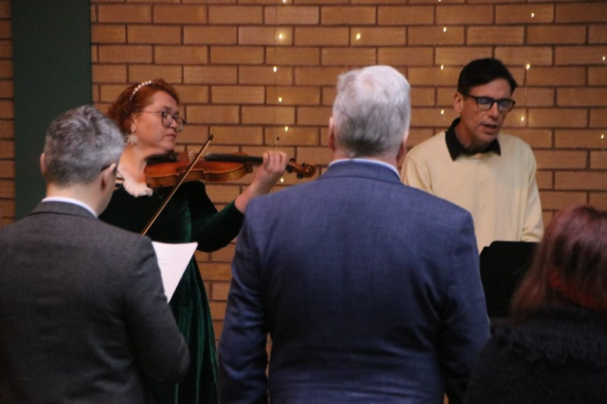

Outcome
Arts in Health work provides and sees creative activities being offered to groups and people who may not normally be offered or have access to the arts. For An Umbrella Against the Rain, an independent evaluation is being completed - the project started in May 2025 and will run until March 2026. The Health Board have year 1 and 2 independent evaluations for the Arts and Minds project demonstrating and evidencing benefits to patients, staff, and the artists involved. Phase 2 work will also include evaluation.
In combination, these projects demonstrate the positive value that Arts in Health can provide in:
- improving healthcare environments,
- changing perceptions of the value of care received
- supporting people to live well, or preventing worsening of their health
- providing avenues for distraction, relief, stimulation, and increasing mood, confidence, and providing pleasure

Children’s and Adolescence Mental Health Service – CAMHS engagement
The charter ensures that children and young people’s views are listened to and involved in their care. During 2024/25, the CAMHS team received feedback from over 1400 children, young people, parents, carers and staff have had their say about services.
Achievements have included supporting the review of the transition policy to ensure patient feedback is embedded. The feedback through surveys has inspired the CAMHS Patient and Experience Team to fundraise to help improve the environments in CAMHS. Staff who have undertaken Children’s Rights Training have reported they feel more confident in using children’s rights in practice.
Linking with our community and learning with them has been invaluable in developing BCUHB services. Services are hearing more voices of children and young people than ever before and are actively embedding engagement into service design and improvement. This helps to ensure that early intervention, prevention, and health promotion is considered. Some key stats about this work includes:
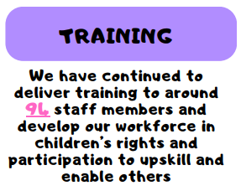
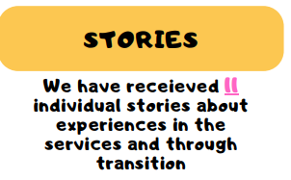

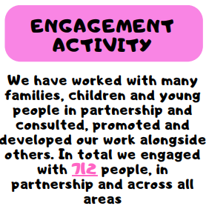
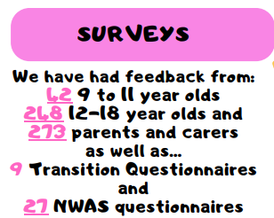

Gypsy, Roma, and Traveller – Health inclusion work

In January 2024, the Health Board established the North Wales Strategic Gypsy, Roma, and Traveller (GRT) Partnership Group with the collective aim of ensuring that the communities experiences are inclusive, fair, and informed by services having an understanding of the Gypsy, Roma and Traveller community.
The group has wide presentation from Local Authorities, Health, Voluntary Sector, Criminal Justice, Police and the Welsh Government National Gypsy, Roma, and Traveller Lead.
The group objectives are to:
- Work collaboratively to address barriers in accessing health, education, housing, employment, and social support.
- Promote the inclusion, equality, and rights of GRT communities.
- Work alongside GRT communities through appropriate and meaningful engagement work to ensure the community’s views and priorities are heard and understood and are used to shape regional priorities.
- Ensure appropriate and continuous feedback loops are in place to report on progress of the group with the GRT community.
- Co-develop a regional action plan to address the needs of GRT communities in north Wales.
- Identify workforce training and development needs and training options to support the programme of work.
- Provide regional leadership and oversight for the delivery of ‘Enabling Gypsy, Roma, and Travellers (Welsh Government) and the BCUHB Gypsy, Roma and Traveller Health Needs Assessment (2023).
- Monitor and interpret data (caravan count, unauthorised encampments, planning submissions) to understand trends in local population and identify appropriate resource.
- Draw on local learning and insights to inform and influence local, regional, and national policy.
- Ensure local strategic GRT groups within Local Authorities are aligned to the aims and objectives of the North Wales Strategic GRT group.
- Identify funding sources to develop joint bids where possible to encourage coordinated and collaborative whole system approaches to supporting GRT communities in north Wales.

Outcomes: Since the group has been established the following has been achieved during 2024/25:

- Our Public Health Directorate have standardised the planning responses for GRT sites ensuring that inclusion health principles are part of the response for planning decisions. This takes account of pollution near busy main roads, safe play areas for children and access to wi-fi for digital inclusion.
- Sharing of data to understand the trends of the local population.
- Establishing links with people from GRT communities to understand their needs and provide ongoing engagement as part of the recommendations from the Health Needs Assessment are worked through.
- Ongoing delivery of the Cultural Competency programme within BCUHB via the Anti-Racist Action Plan.
- Flintshire Council have successfully obtained Welsh Government Capital Grant Funding to develop a new multi-use games area and a safe space for girls at Riverside Traveller site, Queensferry to improve opportunities for young people to be active and improve health and wellbeing. Evidence from the Health Needs Assessment informed the funding application submitted by Flintshire.
- Presented the Health Needs Assessment at the National Inclusion Health Summit in Cardiff and co-presented with Welsh Government at the National Gypsy, Roma, and Traveller Stakeholder Reference Group.
- Evidence from the Health Needs Assessment is being used to inform the refresh of Travelling to Better Health – Guidance for Healthcare Practitioners on Working Effectively with Gypsies and Travellers by Welsh Government.

Photo courtesy of Friends, Families & Travellers: Tackling Suicide Inequalities in Gypsy and Traveller Communities document 2022.

North Wales Access Panel
The Health Board has provided support to the new North Wales Access Panel, which has been launched as part of a two-year initiative to promote inclusivity and accessibility in public spaces including hospitals, libraries, community centres and others. The panel is made up of staff from third sector organisations and was set up and funded by the North Wales Regional Partnership Board (RPB). The panel have received training to effectively carry out surveys of public spaces and provide feedback and recommendations for improvement. The panel is made up of 40 panel members from Disabled People’s Organisations based in north Wales, who received training in November, and a steering group and guidance develop group were formed. By the end of March 2025, the methodology and associated materials, including a handbook and survey template had been agreed, and a draft timetable of surveys had been agreed, spanning hospitals, GP practices, well-being hubs, Welsh Government Offices, Police Stations, and education providers. These will take place through 2025/26.

Palliative Care Workstream

During 2024/25, work has been underway to improve the BCUHB website information about End-of-Life Care for patients of all ages and backgrounds. Review work had initially been identified during 2023 when the Head of Palliative Care met with Equality Stakeholders to discuss the service. The proposed content is now nearing completion and further engagement with a small group of Equality Stakeholders has informed the content, which now includes:

- Care Information for Paediatric Palliative Care
- Services available in north Wales and how the teamwork with other services such as GPs and Community Nursing teams, and hospices
- Equality statements
- Support organisations for patients and carers.
- Chaplaincy and spiritual care
- Advance and Future Care Planning
- Bereavement services and information following a death.

Insight – Interpreter on Wheels

Through our partnership with Welsh Interpretation and Translation Services (WITS)
and Language line introduced digital translation services (video Interpretation) which are accessible via an App on an iPad, Tablet or Smartphone device. This service can provide support in over 120 languages, including British Sign Language (BSL).

During 2024/25 there has been a target roll out of training on how to use this service, following feedback from patients and community groups that patients have had difficulties in accessing services in their community language. With the exception of BSL we have promoted a digital first approach where possible.

Outcome
- Increased staff awareness of the service.
- Decreased rescheduling of patient appointments due to a lack of face-to-face interpretation, e.g. interpreter not booked or no-show.
- Patients being able to access their communication needs.

Engagement

Listening to and understanding the experiences of the people of North Wales is vital to improving the way the Health Board design and deliver care and services. By gathering and analysing insights, we identify the issues that matter most to our population. During 2024/25, the Health Board carried out engagement through:

- Day-to-day interactions with patients, their carers and families
- Feedback from service users, which can come in the form of compliments and complaints
- Conversations with the public and partners in their communities
- Engagement at events. We hosted the “Wellbeing Village” at Denbigh and Flintshire Show on the 15th August 2024. This involved 55 health services, third sector and community organisations.
- Engagement through our digital channels
- Engagement Practitioners Forums with key speakers
- Correspondence from Members of the Senedd and Parliament
- Activities and citizen engagement led by Llais
- Bite Sized Health events – launched October 2024 to promote health and wellbeing with 55 employers attending

Key themes have been identified from Community Conversations, such as access to GP services, waiting times, and communication. Engagement during 2024/25 also provided insight from the population of north Wales about the future of GP services within rural areas, planned developments at the Royal Alexandra Hospital and diagnostic tests for Attention Deficit Hyperactivity Disorder (ADHD) and Autism.

The Board Listening Event in Llandudno Junction July 2024 provided an opportunity to hear what was working well and what could be improved. Key areas such as improving access to NHS Dental Services was raised alongside needing a greater focus on preventative health services. Positive feedback was received about Minor Injury and Minor Ailments Units and the Stanley Eye Unit.

Women’s Health Event
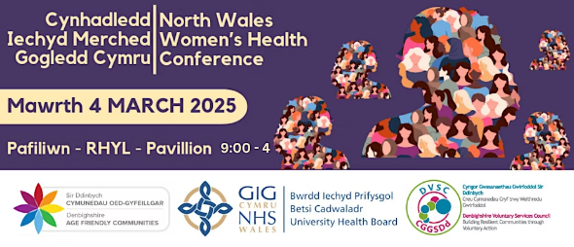
On the 4th March 2025, during International Women’s Week, this conference was organised by DVSC and the Health Board with an attendance of over 350 people. The conference aimed to provide awareness of The NHS Wales Women’s Health Plan 2025-2035 and evidenced based inequitable access to health services for women and girls, with key note speakers from Women’s Health Champions across north Wales alongside the NHS. 70 information stands provided a marketplace for networking and information sharing.

Outcome
- Raise Awareness: Increase community knowledge about women's health issues and available services.
- Enhance Engagement: Foster an interactive environment through social media and event participation.
- Build Community: Continue to build on and raise awareness of current supportive networks for women to share experiences and resources.
- Leverage Partnerships: Collaborate with health organisations and partners to amplify a cohesive message to support women’s health for women in our communities and women in our future generation through life’s course.

Pharmacy in a Box
During 2024/25 the REMEDY Project was underway and provides a technological solution for accessing medications during out of hours and in rural areas. This was a joint project between the Health Board and Bangor University, in collaboration with the manufacturer and supplier and Oxford University and will provide insights into the potential future methods for supplying urgent medicines in rural settings.

People who contact NHS 111 out of hours and require medication urgently in the Dolgellau and surrounding area are offered the option to collect this from the machine outside Dolgellau Hospital, launching this service in July 2024.

Dr Adam Mackridge, Strategic Lead for Community Pharmacy, said: “The patient
is provided with a unique code and is then able to access their medication from the machine at their community hospital.

“It is very simple and will be a huge benefit to the population in the Dolgellau area who are a considerable distance from other services, particularly on weekends and evenings.

“This is a really positive collaboration between ourselves and Bangor University in exploring innovation to try to help improve equity of medicines access and reduce health inequalities.”

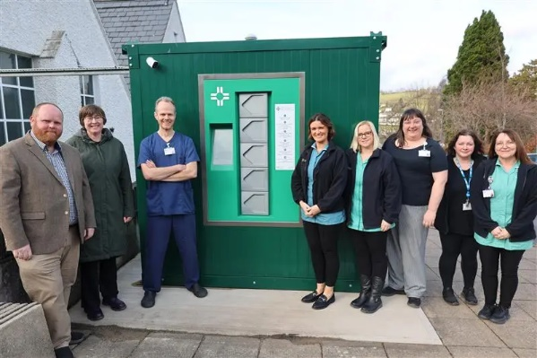

Further information: The REMEDY Project | Bangor University

Establishing an effective environment for learning

Tuberculosis Homeless Bus
During March 2025, the Health Protection Service coordinated a TB and Blood-Borne Virus (BBV) screening event in Wrexham. Equality was a key underlying principle in the planning and delivery of this event. The event was targeted towards individuals facing extreme health inequalities who fit the risk profile for both TB and BBV, including individuals who are homeless, hostel dwellers and individuals experiencing substance misuse. A number of Health Board services and external agencies and third sector organisations came together at short notice to plan, promote and deliver the screening event.

Outcome
Individuals were supported with support to travel and refreshments, to ensure that any identified barriers were addressed. 40 individuals from the target population were screened for both TB and BBV, with 50% of these also accepting Hepatitis B vaccinations. Individuals who tested positive were directed into appropriate follow-up services.

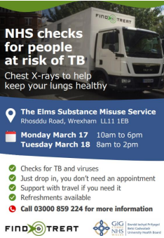
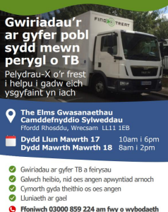
HM Prison and probation service (HMPPS) projects
The Breastfeeding in Prison project is an example of building the evidence base on a key topic that supports the needs of women, and has helped to raise awareness and understanding. The project ran through December 2024 in HMP Berwyn to improve the experience for women visitors to the site. Women were allowed to remain in seat in the visiting hall if needing to breastfeed, using a muslin cloth provided by Barnardo’s. This project is included within the Health Board’s Women’s Plan, and also aligns to several of the strategic objectives in the three-year plan, as well as the strategic Equality objective focusing on achieving equity by working in partnership.

BCUHB Public Health Directorate in partnership with HMPPS published a Health and Social Care Health Needs Assessment (HSCNA) for Approved Premises (previously known as bail hostels) to understand the health and social care needs and experiences of people transitioning from custodial settings to the community. The HSCNA identified unmet healthcare needs in relation to mental health provision, dental health, access to smoking cessation support and medicines management. The findings from this work have informed a multi-agency response to improving continuity of care for people leaving the prison settings into the community.

Outcome

Greater awareness of the importance of breastfeeding among prison workers; support to women who need to breastfeed while visiting prison, to do so without missing visit time. Now been adopted as policy by the prison which is a Breastfeeding Welcome organisation; may be rolled out nationally.

Learning Disability Week

Learning disability week is an opportunity for our Learning Disability teams to increase awareness of the services provided by the Health Board as well as support that is available, including training, promotion of learning disability champions roles. This year was the first year that the Health Board raised the Paul Ridd flag at its three main sites.

In 2024/25, the Public Health Directorate commenced a programme of work to understand the bowel screening pathway for adults with a Learning disability. Through a multi-agency and co-production approach, the programme explores the barriers and facilitators to accessing Learning Disability Annual Health Checks from a person and primary care perspective and through data linkage work, to understand the uptake of bowel screening for adults with a Learning Disability across North Wales – the first of its kind in Wales. The Public Health Directorate has worked in partnership with Conwy Connect, Primary Care Liaison Nurses, Public Health Wales, NHS Performance and Improvement and Digital Data and Technology (DDAT) to develop the programmes aims and objectives.

Outcome
- Increase in staff completing the Paul Ridd e-learning module from 54.05% in April 2024 to 76.05% in March 2025.
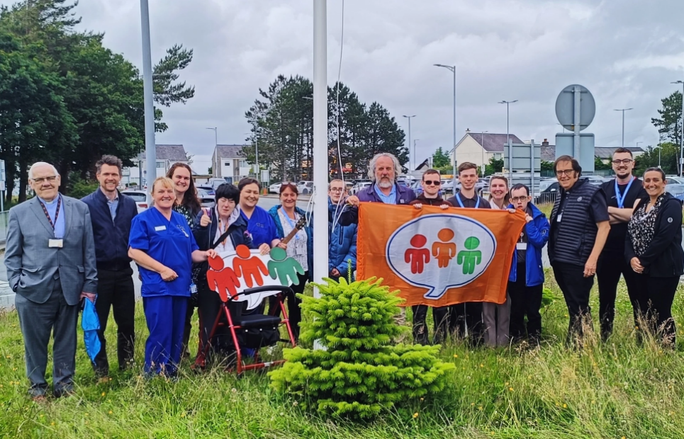
- Increase in learning disability champions to over 250.

Deaf and Wellness Project

The Health Board has partnered with Bangor University as part of a £1m 3-year research grant from the UK Research and Innovation (UKRI) will see an interdisciplinary team working with Deaf British Sign Language-using Communities in Wales in order to tackle health inequalities.

Through the new project, the only one funded by the 3rd and largest and final phase of this funding round in Wales, those involved, including members of the Deaf community, will again be instrumental in co-constructing, co-designing, implementing, and evaluating solutions to known health inequities and inequalities facing Deaf people using British Sign Language (BSL) in Wales. Recognising that Deaf people are at greater risk of underdiagnoses and under-treatment of chronic diseases, tend to have poorer health and are twice as likely to experience mental health problems as the general population.

The project focuses on six areas with the creation of action hubs.

- Environment / access
- Public Health
- Law & Equality
- Interpreting
- Language and Communication.
- Mental Health

Each hub has a number of workstreams.

Outcome
- Development of key research data
- Development of accessible service for Deaf patients to raise concerns.
- Creation of patient focused resources

Equality Training
In 2024/25 The Corporate Equality Team delivered equality training to 718 members of staff.
The training offer and numbers are summarised below:
Active Bystander | 242
Neurodivergence | 212
EqIA/SEIA | 22
General Equality Training | 97
LGBTQ+ | 61
Menopause | 0
Endometriosis | 16
Incel Awareness | 35
Inclusive Workplaces | 33
TOTAL | 718

During this reporting period the Health Board approved for a Culture, Education and Training Lead (Equality) post to be established in the Corporate Equality Team.
The Health Board has also developed a range of sessions and tools around menopause support.
During 2024-25 the Health Board delivered:
- General menopause awareness – 3 sessions
- Menopause awareness for managers & team leaders – 3 sessions
- Menopause management; Lifestyle & Nutrition – 9 sessions
- Menopause Champions – 1 session
- Menopause and intimacy – 1 session
The Menopause live roadshow was held in November, and we engaged with over 400 staff members over the week;
- Hybrid awareness sessions/Drop-in clinics – 65 staff members
- Departmental closed sessions – 29 staff members; Sessions were delivered to the Occupational Health department, Maesderw community Nurses (Llandudno) and Flintshire mental health team
- Roadshow stands across sites – Approx. 325 staff members

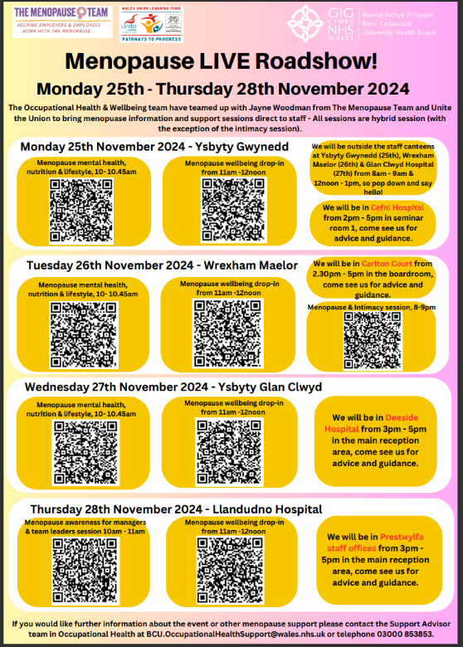

There were 7 requests from the following departments to arrange awareness sessions in 2025;
- Conway West Cluster (GP Collaborative)
- YGC North Wales Cancer Centre
- Medicine department at Wrexham Maelor
- Ysbyty Glan Clwyd Eye teams
- Ysbyty Gwynedd Catering teams
- Ysbyty Glan Clwyd Renal unit
Equality Impact Assessments and Socio-economic Impact Assessments
During 2024/25 the process for Equality Impact Assessments (EQIA) and Socio-economic Impact Assessments (SEIA) were revised to be incorporated into one template for useability, with an increased focus on equality risk, alignment with the Socio-economic Duty and intersectionality. The Health Board values, and current Strategic Equality Objectives were also included, so that those completing the forms had a better understanding of where Equality and Socio-economic factors fit into the bigger picture of service delivery and decision making.
During 2024/25 the Health Board undertook approx. 267 Integrated Equality Impact Assessments and progressed towards a universal database/Library for assessments.

Section 4: Priorities for the Year Ahead 2025/26

The focus for 2025/26 is on dismantling the systemic barriers our staff face within the workplace, through processes and procedures that prevent staff from fulfilling their true potential and linking to the Health Board’s culture workstreams and values and behaviours framework.

In the first year of the Strategic Equality Action Plan, 28 actions were established. Through continued engagement and dialogue with stakeholders, an additional three actions have been added in the second year, reflecting evolving priorities and needs. At the heart of all workstreams is a commitment to co-producing solutions that address and reduce health inequalities.
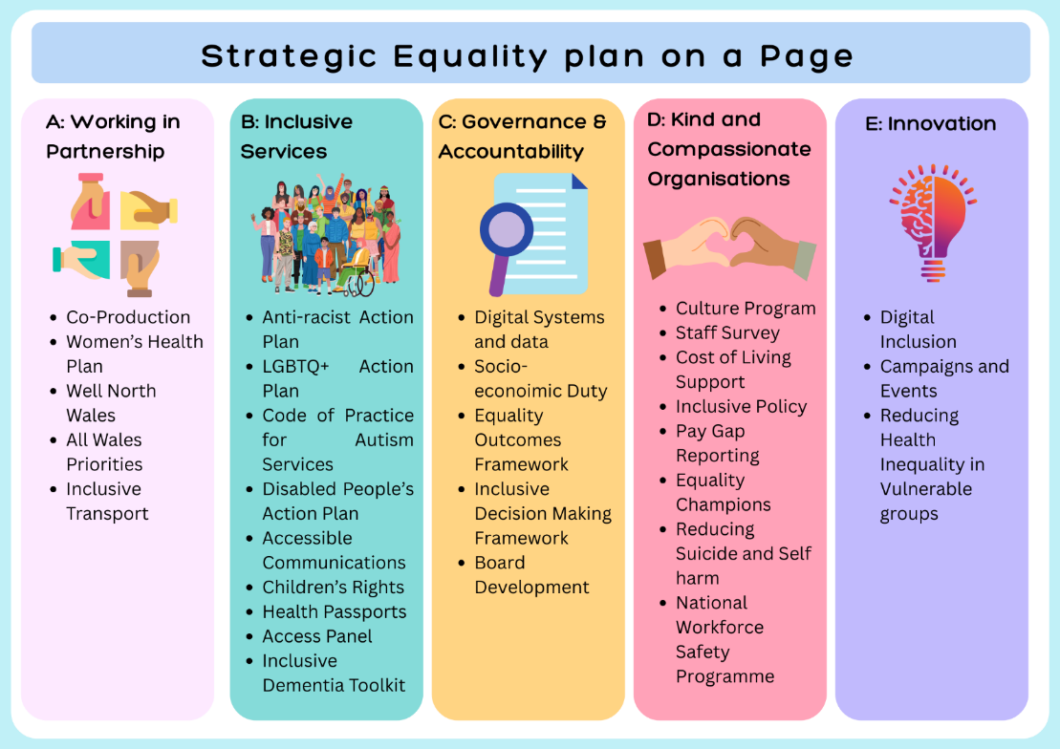
Achieving this requires a dual approach: one that acknowledges the disproportionate impact of the social determinants of health, and another that actively tackles the known barriers to accessing healthcare services.

Section 5: Conclusion

This Equality Annual Report highlights key areas of work undertaken by the Health Board in partnership with others to advance equality, promote human rights, and address health inequalities. Over recent years, the Health Board has responded to a growing number of Welsh Government strategies, including the Anti-Racist Wales Action Plan, the LGBTQ+ Action Plan for Wales, and the Code of Practice on the Delivery of Autism Services.
The recent review of the Accessible Communication Standards and the publication of the Disability Action Plan are expected to further expand the scope of equality, diversity, and inclusion actions and recommendations across the organisation.

Key Priorities for 2025/26 include:
- Review inclusive recruitment, progression and retention.

In response to the findings of the Health Board’s Workforce Race Equality Standard (WRES) report, a dedicated group has been established to review inclusive recruitment, progression, and retention practices. The data identified a need to examine and improve key processes to ensure they are equitable and inclusive.
Once the review is complete, targeted actions will be implemented to address any areas requiring improvement. Over the course of the Strategic Equality Plan, the Health Board aims to see increased representation throughout all stages of recruitment, enhanced progression opportunities, and improved retention rates across the workforce.

- Focus on improvement of baseline equalities data and its analysis.
Baseline data analysis for both staff and patients has highlighted the need to improve the response rate for equality data collection. Increasing the uptake of this data is essential to enabling the Health Board to develop meaningful indicators that reflect progress, identify areas for improvement, and better represent the diversity of our workforce and patient population.
Over the lifetime of the Strategic Equality Plan, the Health Board aims to see a significant increase in the completeness and quality of baseline equality data.

- Analysis of Equality based pay gap data
Equality pay gap data, sourced from the Electronic Staff Record (ESR), has highlighted key areas requiring attention—particularly diversity across pay bands, the impact of flexible working arrangements, and gaps in reporting due to under-submission of equality information. A targeted campaign, as outlined above, aims to improve data collection, enabling the Health Board to develop meaningful indicators that reflect progress and better represent the diversity of its workforce.
To address these issues, the Health Board will establish a Pay Gap Action Plan focused on:
- Enhancing diversity within pay bands.
- Understanding and mitigating the impact of flexible working on equality-based pay gaps.
- Supporting underrepresented staff to access leadership development opportunities, with a particular emphasis on non-academic leadership programmes for those without university qualifications.
Over the lifetime of the Strategic Equality Plan, the Health Board expects to see:
- Improved baseline equality data.
- Greater insight into the effects of flexible working.
- Increased uptake of personal development opportunities among underrepresented staff groups.

- Focused Engagement with underrepresented groups

As part of the Special Measures Framework, the importance of meaningful engagement, strong relationships, effective partnerships, and clear communication was highlighted in an independent review by Cath Broderick, a consultant specialising in patient and public engagement. In response, the Health Board established the BCUHB Engagement Group in co-production with Llais Wales to explore how engagement and relationships can be strengthened and made more impactful.
In 2025, the Health Board will host a series of equality-focused health fairs aimed at bringing communities together. These events are expected to foster stronger relationships with external stakeholders and support the co-production of resources designed to reduce health inequalities and increase awareness and uptake of services among underrepresented groups.
A key challenge for the Health Board is to ensure these emerging priorities are embedded within the planning framework and reflected in future Three-Year Plans. This includes actively identifying and addressing the policies, behaviours, and beliefs that perpetuate discrimination and inequality, and ensuring equitable access to services.
The Health Board’s People Strategy underpins a range of actions to improve recruitment, retention, and development opportunities for staff. Significant progress has been made in improving monitoring data and aligning this work with the Equality Strategy. The Health Board is committed to being an employer of choice—free from discrimination, harassment, and victimisation—and led by compassionate leadership.
The appointment of an Executive Champion for Equality in 2025 marks a positive step toward strengthening executive-level accountability for the equality agenda, including key areas such as the Welsh Government’s Anti-Racist Wales Action Plan and LGBTQ+ Action Plan.
Co-production has been central to the progress made under the Strategic Equality Plan, with stakeholders playing a vital role in holding the Health Board to account and shaping guidance informed by lived experience.
The Health Board is deeply grateful for the time, challenge, and ongoing scrutiny provided by stakeholders. Their continued support will be critical as we move into Year Two of the Strategic Equality Plan.

Acknowledgements
The Health Board are grateful for all the support that we receive from all of our stakeholders who represent a diverse and inclusive range of organisations and people, including:
- Autistic UK
- Age Cymru
- North Wales Independent Advocacy Service
- Unique Transgender Network
- North Wales Trans, Intersex and Non-binary Network
- Llais
- North Wales Regional Equality Network
- Wheelieability
- Arfon Access Group
- FDF Centre for Independent Living
- STAND North Wales
- Fair Treatment for Women in Wales
- Centre for Sign Sight Sound
- Victim Support
- EYST
- BAWSO
- Race Council Cymru
- Race Equality First
- North Wales Africa Society Disability Wales
- Bangor Indian Friends Association
- North Wales Ethnic Multicultural Association
- North Wales Interfaith
- Papyrus
- Epilepsy UK
- ARA – Recovery For All
- Viva
- Shelter
- Vision Support

The Health Board would also like to acknowledge the support of every member of our staff networks and Equality Champions:
- Celtic Pride,
- BCUnity and International Staff network,
- RespectAbility,
- The Gender Equality Network,
- ND Network
- Veterans Staff Network.
- Equality Champions

Finally thank you to all those staff, of whom there are too many to mention, who have made a positive contribution to advancing Equality and Human Rights this year.

Appendices

Appendix A: Population information

Appendix B: Equality legislation and Strategic Context

Appendix C: BCUHB Vision, Values and Purpose

Appendix D: Equality Matrix

Appendix A: Population information
A snapshot about North Wales: Source: Nomis 2022

Across North Wales, Flintshire has the largest population (156,100) followed by Wrexham (135,957). Anglesey has the smallest population at 70,043.

Flintshire and Wrexham also have a younger population with 19% of the population aged 15 years and under, and Anglesey and Conwy have an older population with 26% and 28% respectively aged 65 and over. Conwy also has the greatest percentage of people aged 85 and over at 4% of the population.
Percentage of age groups - North Wales
25.0
20.0
15.0
10.0
5.0
0.0
4 5 to 9 10 to 16 to 20 to 25 to 35 to 50 to 65 to 75 to
years and under
15
85
19 24 34 49 64 74 84 and
over
BCUHB area
Wales


Welsh speakers:

North Wales is home to more Welsh-language speakers than elsewhere in Wales. The highest percentages of people (across Wales) aged three years or older able to speak Welsh were in North-West Wales, with 64.4% in Gwynedd, and 55.8% in Anglesey.


A snapshot of our demographics

No religion - 47.1%
Sexual Orientation Gay or Lesbian 1.3% Bisexual 1.0%
Pansexual 0.1%
Asexual 0% (269)
Queer 0% (88)
Other 0% (59)
No answer 8.1%
Heterosexual 89.4%


Religion
Christian – | 49.8%
Muslim - | 0.8%
Hindu - | 0.2%
Sikh - | 0% - 248
Jewish - | 0% - 311
Buddhist - | 0.3%
Other - | 0.5%

Sex / Gender
Male 48.9%
Female 50.1%


Gender identity Trans - 703 people Non-Binary – 254 people
Not answered – 39,253 people

Caution should be taken with LGBTQ+ census data as this is considered as significantly underestimated.

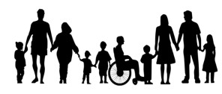
Ethnicity
White – 96.8% compared to Wales 93.8%
Asian, Asian British or Asian Welsh – 1.4% compared to Wales 2.9%
Black, Black British, Black Welsh, Caribbean or African – 0.3% compared to Wales 0.9%
Mixed or Multiple ethnic groups – 1.1% compared to Wales 1.6% Other ethnic group – 0.4% compared to Wales 0.9%
Disability / long term conditions and impairments 72,235 people
10.5% as
defined under the Equality Act Carers 10.3%
>19 hours of care per week

Map showing Lower Super Output Areas by fifths of deprivation, Overall Welsh Index of Multiple Deprivation, North Wales, 2019¹

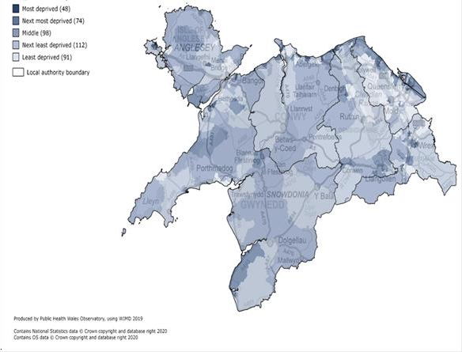

¹ Source: WIMD - Explore (gov.wales)


Appendix B: Equality Legislation and Strategic Context

The Equality Act 2010

The Equality Act 2010 protects people, groups from unfavourable treatment, and makes it unlawful to discriminate, harass or victimise people because of a reason related to their protected characteristic.

The Public Sector Equality Duty

Section 149 of the Equality Act 2010 requires us to demonstrate compliance with the Public Sector Equality Duty (PSED), which places a statutory duty on the Health Board to:
- Eliminate unlawful discrimination, harassment, and victimisation.
- Advance equality of opportunity between persons who share a relevant protected characteristic and those who do not.
- Foster good relations between those who share a relevant protected characteristic and those who do not.

Our Health Board also has a specific duty under the PSED to undertake the following actions:

- Publish information to demonstrate compliance with the Equality Duties, at least annually.
- Set equality objectives, at least every 4 years.

The Socio-economic Duty

The Socio-economic Duty was introduced by the Welsh Government on 31st March 2021, implementing a previously dormant section of the Equality Act (2010). Its aim is to deliver better outcomes for those who experience socio-economic disadvantage. It further enhances current equality legislation and the Well-being of Future Generations (Wales) Act 2015 and Social Services and Well-being (Wales) Act 2014. The Socio- economic Duty places a requirement on the Health Board that when taking strategic decisions, the Health Board has due regard for the need to reduce inequalities of outcome that result from socio-economic disadvantage.

The Human Rights Act 1998

The Human Rights Act 1998 sets out universal standards to ensure that a person’s basic needs are recognised and met. Public Bodies have a mandated duty to ensure they have arrangements in place to comply with the Human Rights Act 1998. It is
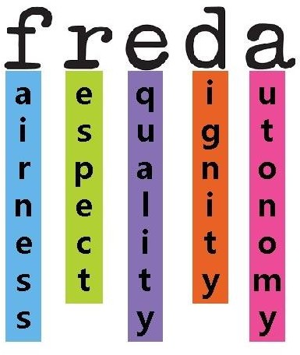
unlawful for a healthcare organisation to act in any way that is incompatible
with the Human Rights Act 1998. In practice, this means we must treat
individuals with Fairness, Respect, Equality, Dignity and
Autonomy. These are known as the FREDA principles. Infographic courtesy of CQC

All Wales Standard for Accessible Communication

An All-Wales Standard for Accessible Communication and Information for People with Sensory Loss produced by Welsh Government (2013) sets out the level of service people with sensory loss should expect to be met whey they access health care. These standards apply to adults, young people, and children.

Armed Forces Act 2021

The covenant aims to prevent service personnel and veterans and their families being disadvantaged when accessing public services. This introduced a statutory duty to have “due regard” to the principles of the Armed Forces Covenant.

Welsh Government - Anti-racist Wales Action Plan

In June 2022, the Welsh Government published the “Anti-racist Wales Action Plan”. The Anti-Racist Wales Action Plan places a responsibility on public bodies to report demonstrable progress in areas detailed in specific actions. Health is one of the component parts of the plan, and BCUHB will be undertaking the actions contained within the five Health priority action areas:

- Leadership
- Workforce.
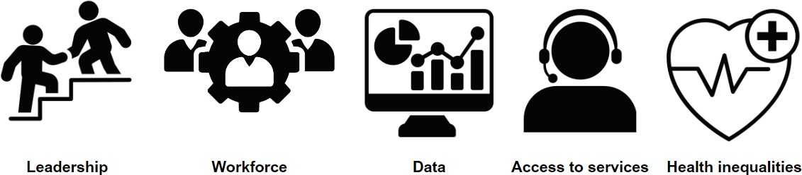
- Data.
- Access to services.
- Health Inequalities.

Welsh Government – LGBTQ+ Action Plan

On the 7th February 2023, the Welsh Government published the LGBTQ+ Action Plan. The Welsh Government has said that it “wants to make Wales the most LGBTQ+ friendly nation in Europe” with the stated aim “to show our clear commitment to respecting, protecting, and fulfilling the human rights of all LGBTQ+ people in Wales.”
Health is one of the component parts of the plan.

The Welsh Government wants to make Wales the most LGBTQ+ friendly nation in Europe. It is an ambitious goal, but we believe we can support all LGBTQ+ people in Wales to live their fullest life: to be healthy, to be happy, and to feel safe. This LGBTQ+ Action Plan for Wales has been established to help coordinate action by the Welsh Government and other agencies. The plan sets out an overarching vision to improve the lives of and outcomes for, LGBTQ+ people. It includes a wide range of policy-specific actions relating to human rights, education, improving safety, housing, health and social care, sport, culture, and promoting community cohesion.
Health is one of the component parts of the plan, and BCUHB will be undertaking the actions contained within the heath related actions:
- Understand and improve the experience of LGBTQ+ people in the health and social care sectors.
- Ensure maternity and fertility services are accessible and straightforward to use for LGBTQ+ people.
- Ensure the development of the new mental health strategy takes account of LGBTQ+ people.
- Publish and act on a new HIV Action Plan and overcome barriers to LGBTQ+ people accessing sexual health services.
- Review the Gender Identity Development pathway for young people in Wales.
- Continue to develop the Wales Gender Service.
- Improve the data recording and change processes for maintaining trans, non-binary, and intersex people’s medical records.

BCUHB Strategic Equality Plan

As a listed body in Wales under the Equality Act 2010, we are required to draw up a Strategic Equality Plan at least every 4 years.

The purpose of the Strategic Equality Plan is to document the steps that BCUHB is taking to fulfil its duty. During 2023-24 the Health Board engaged widely to develop the SEP for the next 4 years. This was published on the 28th March 2023. BCUHB Strategic Equality Objectives and Plan 2024-28

Appendix C: BCUHB Vision, Values and Purpose

For more information visit: About the Health Board.

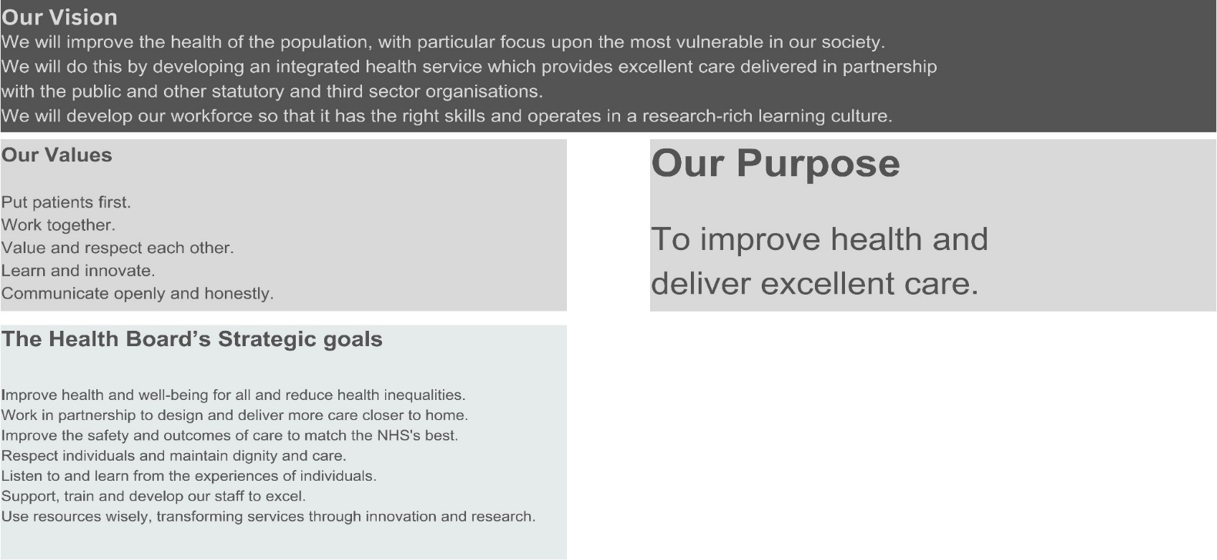

Appendix D: Equality Matrix
Strategic Objectives & Strategic Equality Plan: Year 2 Priority Alignment

For the period relating to this Annual Equality Report the Health Board had the following stated Strategic Objectives as published in the Three-year plan 2024-2027.
Priority |  | 1 | 2 | 3 | 4 | 5
A1 | To identity opportunities in embedding principles of co-production and co design for transformation programmes, strategy development, service planning and review and key guidance and reports. |  |  | 
A2 | Progress actions within the 8 priority areas within The NHS Wales Women’s Health Plan 2025-2035 published December 2024.
A4 | Use the Well North Wales programme to work with partners to further develop system approaches to reducing health inequalities.
A5 | BCUHB to continue to actively influence and support Wales NHS Equality Leadership Group.
A7 | Explore partnership opportunities with transport for Wales to meet patient needs for accessible and inclusive travel for specialised services
B1a | To implement BCUHB Anti racist Action Plan.
B1b | To engage with and undertake actions identified by the Wales Workforce Race Equality Scheme
B2 | To develop and implement BCHUB LGBTQ+ Action Plan.
B3 | To implement BCUHB Code of Practice for Autism Services.
B4 | To review the findings of the Welsh Government Disability Rights Task Force and implement any recommendations.
B5 | Ensure the availability of accessible information to patients and carers in line with the Accessible Communication Standards, including BSL charter and Welsh Language standards
B6 | Embed the ‘Build it Right’ Children’s Rights principles across transformation programmes.
B7 | Implement a My Health Passport system – All About Me, across Primary and Secondary Care
B8 | To implement the north Wales Accessibility Panel project
B9 | Develop an Inclusive Dementia Development Programme and Toolkit
C1 | Improve BCUHB digital systems and processes to record and monitor patient and workforce equality data to inform intelligence led planning.
C2 | To strengthen compliance with the Socio-economic Duty.
C3 | Agree and implement the Equality Outcomes Framework through directorates
C4 | Develop and embed an equality and human rights-based framework for inclusive decision making, for project management processes, pathway review and procurement.
C5 | To deliver regular equality education sessions to the Board to embed equality and human rights duties
D1a | Embed equality principles and outcomes within the BCUHB culture change programme.
D1b | Respond to equality related feedback from the Staff Survey 2024/25
D2 | Improve the support for staff facing socio-economic disadvantage.
D3 | Review all Recruitment and HR policies and processes from an anti-racist perspective.
D4 | Publish pay gap reports for gender, race, and disability to further inform workforce planning to reduce pay gaps.
D5 | Develop role of Equality and Inclusion Champions across the BCHUB workforce.
D6 | Reducing suicide and self-harm inequality
D7 | Influencing National Workforce Safety programme with an EDI focus and implementing findings
E1 | Implement Digital Inclusion Programme
E3 | To increase awareness of equality campaigns and events aligned to BCUHB strategic priorities.
E4 | Reducing health inequalities in vulnerable groups

1: Building an effective organisation

