Ein cyf / Our ref: 126/22/FOI
Dyddiad / Date: 18th August 2022

Further to your request for information dated 7th July 2022, I am pleased to provide the following response. Please accept our apologies for the delay.

Your request and our response:
I would like to make an FOI request relating to the local treatment guidelines currently in place at your organisation, this request is in three parts.

Part 1: Please can I enquire if your organisation has any local treatment guidelines for following conditions:

Therapy Area | Does your organization have local treatment guidelines for this condition? Yes/No | If Yes please supply URL or provide a copy as an attachment
Inflammatory Bowel Disease | No
Ulcerative Colitis | Yes | 
Crohn’s Disease | Yes | 

Part 2: You have previously responded to a number of FOIs relating to the treatment of other conditions. In each instance no local guidelines for the treatment of these conditions were available. Please can I enquire if any local guidelines for the treatment of these conditions have been published since your previous response.

Therapy area | Previous FOI response | Date | Have any local guidelines been published since previous FOI response? Yes/No  If Yes please supply URL or provide a copy
Diabetes | No local guidelines | February 2018 | 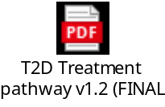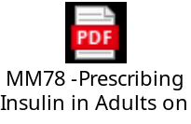
Axial Spondyloarthritis (AxSpA) including Ankylosing Spondylitis (AS) | No local guidelines | 10/03/2021 | No Local guidelines
Asthma | No local guidelines | February 2019 | 
Lipid Lowering | No local guidelines | May 2020 | 
Rheumatoid Arthritis | No local guidelines | 10/03/2021 | 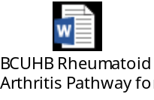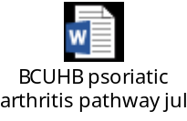
Heart Failure | No local guidelines | December 2020 | 

Part 3: For the following conditions you previously responded that a local guideline was available please can you confirm if these guidelines are still place or if they have been updated.
Therapy area | Document title | FOI Date | Publication date | Review Date | Has this document been updated? (Yes/No)
COPD | COPD Management and prescribing guide | October 2016 | May 2022 | May 2025 | No
Osteoporosis | Clinical Guidelines for the Management of Osteoporosis | March 2020 | July 2021 | July 2023 | Yes
Psoriatic Arthritis | Approved BCUHB treatment pathway for psoriatic arthritis. | October 2020 | September 2021 | September 2024 | Yes
Psoriasis | Psoriasis: BCUHB treatment pathway in patients aged 18 or over | October 2020 | August 2020 | August 2023 | No

